# TASK-1

**Title: Create a webpage that includes a scrolling header message, a table displaying details of your favorite movies (such as name, genre, year, and rating), an image of your favorite actor/actress, a movie trailer video with controls, and an audio player for a movie soundtrack that auto-plays when the page loads**

**Source code:**

<!DOCTYPE html>

<html>

<head>

<title>TASK1</title>

</head>

<body>

<marquee><h1>WELCOME TO MY WEBPAGE</h1></marquee>

<h1><center>Moviez Wood</center></h1>

<table border="1" width="50%">

<tr>

<th>Name</th>

<th>Genre</th>

<th>Year</th>

<th>Rating</th>

</tr>

<tr>

<th>HIT-3</th>

<td>Crime Thriller</td>

<td>2025</td>

<td>7.4/10</td>

</tr>

<tr>

<th>Salaar</th>

<td>Action & Thriller</td>

<td>2023</td>

<td>6.7/10</td>

<tr>

</tr>

<th>KGF-1</th>

<td>Action & Drama</td>

<td>2018</td>

<td>8.2/10</td>

</tr>

</table><br><br>

<img src="Mahesh Babu.jpeg"> <br>

<audio src="Ranjhaan.mp3" autoplay="autoplay" loop="loop"controls> Your browser does not support the audio element.

</audio><br>

<iframe width="560" height="315" src="https://[www.youtube.com/embed/_InqQJRqGW4?si=Z3EYcus9ZYMUl0dl"](http://www.youtube.com/embed/_InqQJRqGW4?si=Z3EYcus9ZYMUl0dl) title="YouTube video player" frameborder="0" allow="accelerometer; autoplay; clipboard-write; encrypted-media; gyroscope;

picture-in-picture; web-share" referrerpolicy="strict-origin-when-cross-origin" allowfullscreen></iframe>

<br><br>

</body>

</html>

**Output:**

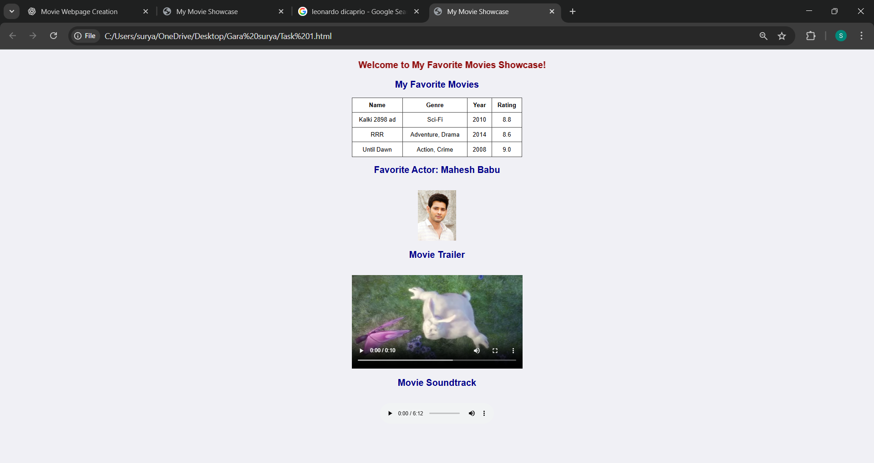

# TASK-2

**Title: Design a webpage that includes a horizontal navigation menu with links to "Home," "About," "Services," and "Contact," followed by a section that displays a list of your favorite books in a neat table with columns for Title, Author, and Genre. Below the table, insert an image of the book cover for one of the books, a video review of the book, and an audio clip of an author interview.**

**Source code:**

<!DOCTYPE html>

<html>

<head>

<title>TASK2</title>

<meta charset="utf-8">

<meta name="viewport" content="width=device-width,initial-scale=1">

</head>

<body>

<table width="100%" height="50px" border="3">

<nav>

<td ><a href="">Home</a></td>

<td><a href="">About</a></td>

<td><a href="">Services</a></td>

<td><a href="">Contact</a></td>

</nav>

</table><br><br>

<h1>Click below to Visit my Library</h1>

<a href="newlist.html">My Books</a>

</body>

</html>

**Second Page for link: newlist.html Source code:**

<!DOCTYPE html>

<html>

<head>

<title>List of books</title>

</head>

<body>

<h1><center>Library</center></h1>

<table border="2">

<tr>

<th>Book-Title</th>

<th>Author</th>

<th>Genre</th>

</tr>

<tr>

<th>Rich Dad Poor Dad</th>

<td>Robert Kiyosaki</td>

<td>Personal Finance Book</td>

</tr>

<tr>

<th>The Great Gatsby</th>

<td>F.Scott Fitzgerald</td>

<td>Novel</td>

</tr>

<tr>

<th>Moby-Dick</th>

<td>Herman Melville</td>

<td>Adventure</td>

</tr>

<tr>

<th>War and Peace</th>

<td>Leo Tolstoy</td>

<td>Historical Novel</td>

</tr>

<tr>

<th>rime and Punishment</th>

<td>Fyoder Dostoevsky</td>

<td>Philosophical Novel</td>

</tr>

</table><br><br>

<div>

<img src="rich.jpg" width="20%" height=300px>

<iframe width="560" height="315" src="https://[www.youtube.com/embed/8Sxm_GZBduU?si=XrhZTIHpHhR0Xj4L"](http://www.youtube.com/embed/8Sxm_GZBduU?si=XrhZTIHpHhR0Xj4L) title="YouTube video player" frameborder="0" allow="accelerometer; autoplay; clipboard-write; encrypted-media; gyroscope;

picture-in-picture; web-share" referrerpolicy="strict-origin-when-cross-origin" allowfullscreen></iframe><br>

</div>

<audio src="richdad.mp3" controls></audio>

</body>

</html>

**Output:**

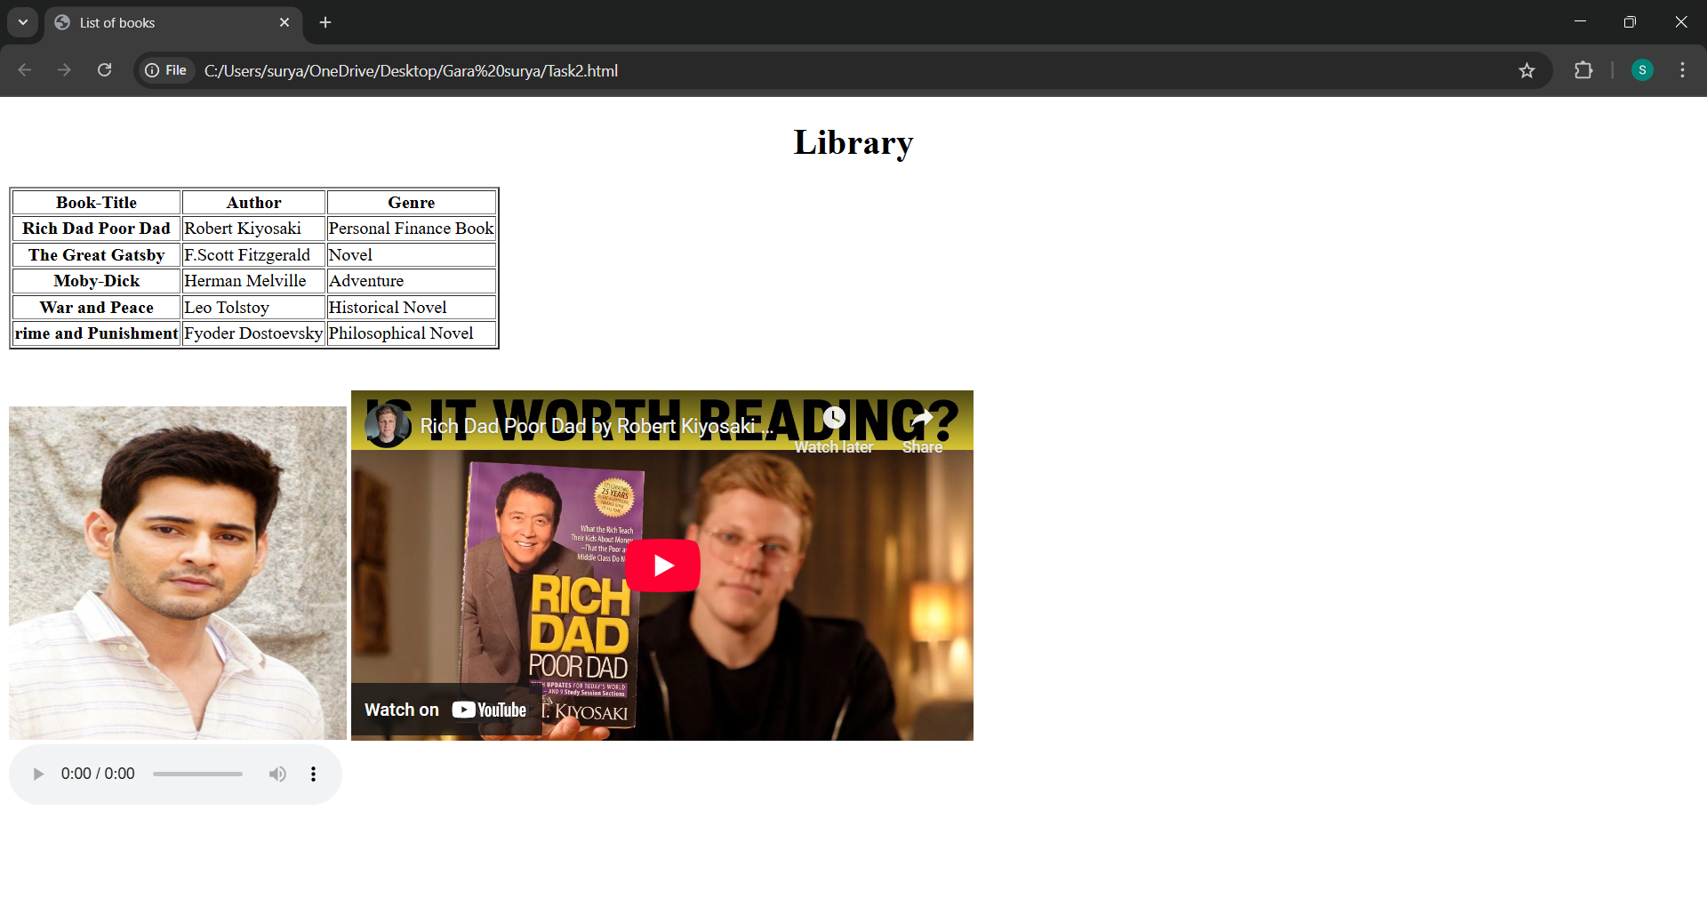

# TASK-3

**Title: Create a portfolio webpage with a header that scrolls a welcome message across the screen, followed by a section that includes a table of your recent projects with columns for Project Name, Description, and Date. Below the table, add an image of a screenshot from one of the projects, a video tutorial on the project, and an audio description of the project**

**Source code:**

<!DOCTYPE html>

<html>

<head>

<title>TASK3</title>

</head>

<body>

<marquee><h1>This is my Portfolio Page</h1></marquee>

<h1>Tap here to visit my Projects...</h1>

<a href="newpage.html">My projects</a><br><br><br>

<h1>Click below to see my Video Tutorial and for detail Audio Description...</h1>

<a href="sample1.html">Project Summarization Audio</a>

</body>

</html>

**Second link page:newpage.html Source code:**

<!DOCTYPE html>

<html>

<head>

<title>Example Webpage</title>

</head>

<body>

<h1><center>My Projects</center></h1>

<table border="2" width="50%">

<tr>

<th>Project Name</th>

<th>Description</th>

<th>Date</th>

</tr>

<tr>

<th>Class Time Table</th>

<td>To prepare this time table we have to use Table tag.<br> It gives the correct timings for the students which class it is</td>

<td>13-5-2025</td>

</tr>

<tr>

<th>Moviez Wood</th>

<td>Adding Movies into our page and we will<br>add trailers and hero picture<br>with an audiotrack. </td>

<td>16-5-2025</td>

</tr>

<tr>

<th>Library</th>

<td>Here we Stored some Novels,Adventure& Financial Books.<br>You can check the author of the book,<br>and can check

the genre as per your taste.<br>Here we added a sample cover page,a trialer,and an interview audio of <br>an author</td>

<td>16-5-2025</td>

</tr>

</table><br><br>

<h3>This is Sample image of my library project</h3>

<img src="tsk-3.png" width="50%">

</body>

</html>

**Third page link: sample1.html Source code:**

<!DOCTYPE html>

<html>

<head>

<title>Sample Page</title>

</head>

<body>

<h1><center>My library project Summarization in Audio</center></h1>

<audio src="projectaud.mp3" controls></audio><br>

<h1><center>Sample Video</center></h1>

<video src="library.mp4" width="50%" height=300px controls></video>

</body>

</html>

**Output:**

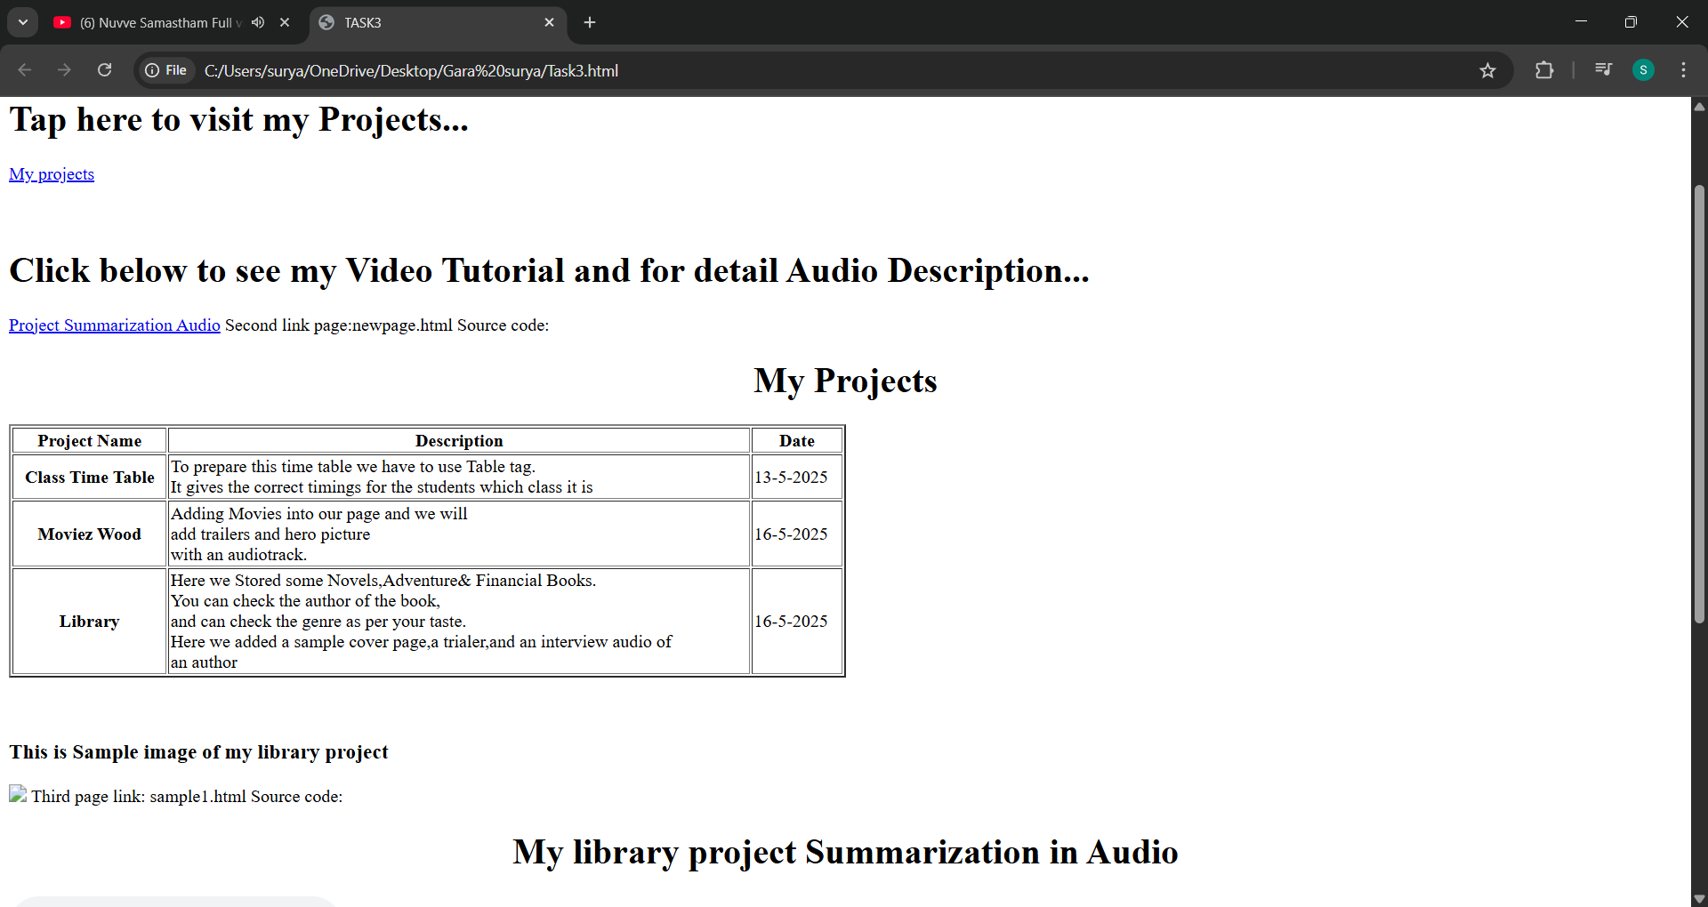

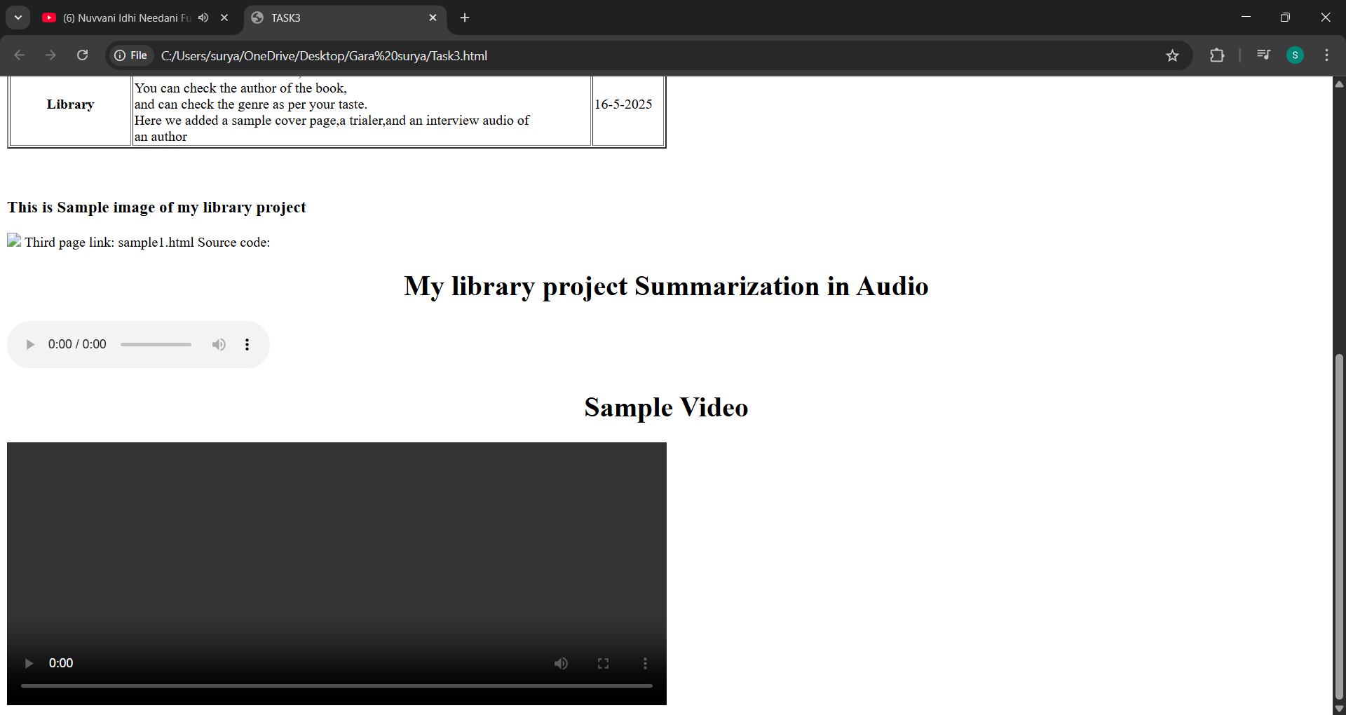

**3**

**Title: Create a basic HTML page introducing yourself. Design a webpage using appropriate HTML tags that displays: Your full name as a heading. A short paragraph describing yourself. A list of your hobbies using an unordered list**

**Source code:**

<!DOCTYPE html>

<html>

<head>

<title>TASK4</title>

</head>

<body>

<header><h1>Gara surya</h1></header>

<p>My Name is Surya. I am from Srikakulam.</p>

<h3>My Hobbies::</h3>

<ul>

<li>Playing Video Games</li>

<li>Social Networking</li>

</ul>

</body>

</html>

**Output:**

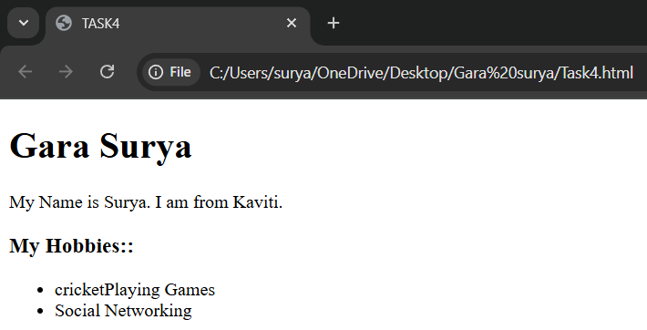

**4**

**Title: Create a simple resume web page using HTML. The resume should include: Your name in an <h1> tag. A bio/summary using the <p> tag. A list of your skills using an**

**unordered list. A list of your qualifications using an ordered list Source code:**

<!DOCTYPE html>

<html>

<head>

<title>TASK5</title>

</head>

<body>

<h1>Gara surya</h1>

<p>

My Name is Surya. I'm from Srikakulam. Currently i'm doing Under Graduation.

</p><h2>Skills::</h2>

<ul type="square">

<li>C</li>

<li>Python</li>

<li>HTML</li> </ul>

<h2>My Qualifications:: </h2>

<ol>

<li>Intermediate</li>

<li>SSC</li> </ol>

</body>

</html>

**Output:**

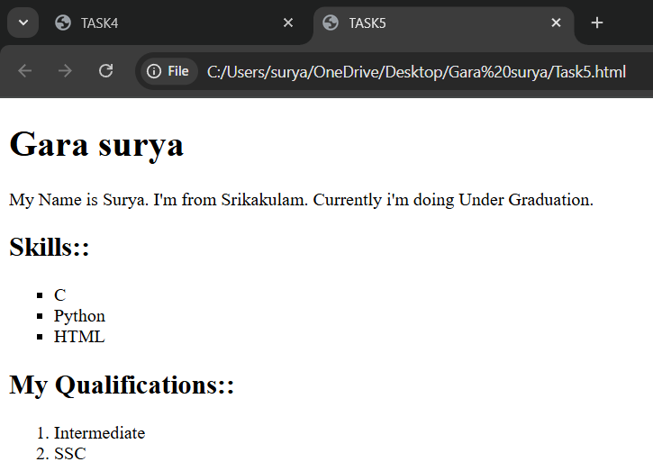

**5**

**Title: Create a paragraph demonstrating the following text formatting tags: <b>, <strong>,**

**<i>, <em>, <u>, <mark>, <small> Source code:**

<!DOCTYPE html>

<html>

<head>

<title>TASK6</title>

</head>

<body>

<p>

<h3>This paragraph is about to test different <q>Text Formatting</q> tags.</h3>

<b>The warm sun kissed the morning, chasing away the shadows.</b><br><br>

<strong>Birds sang a sweet melody, a symphony of nature's delight.</strong><br><br>

<i>The gentle breeze whispered secrets through the rustling leaves.</i><br><br>

<em>A path of wildflowers led to the village, a vibrant tapestry of colors.</em><br><br>

<u>A dog barked happily, greeting the day with joyful enthusiasm.</u><br><br>

<mark> The aroma of freshly baked bread wafted from the kitchen window.</mark><br><br>

<small> Life unfolded in peaceful rhythm, a beautiful and serene scene. </small><br><br>

</p>

</body>

</html>

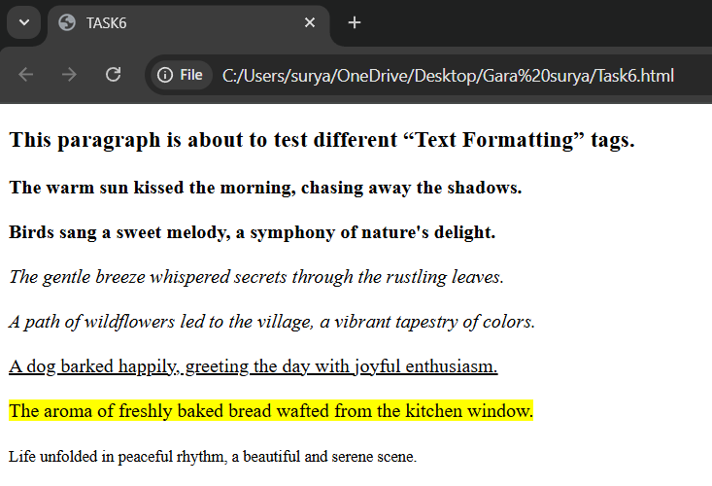**Output:**

**6**

**Title: Create a nested list of a shopping category. The main list should have categories like Fruits, Vegetables, Electronics. Each category should include 3 relevant items using nested lists.**

**Source code:**

<!DOCTYPE html>

<html>

<head>

<title>TASK7</title>

</head>

<body>

<ol>

<li>Fruits</li>

<ul type="square">

<li>Mango</li>

<li>Apple</li>

<li>Banana</li>

</ul>

<li>Vegetables</li>

<ul type="circle">

<li>Tomato</li>

<li>Potato</li>

<li>Onion</li>

</ul>

<li>Electronics</li>

<ul type="disc">

<li>Mobile</li>

<li>Laptops</li>

<li>Television</li>

</ul>

</ol>

</body>

</html>

**Output:**

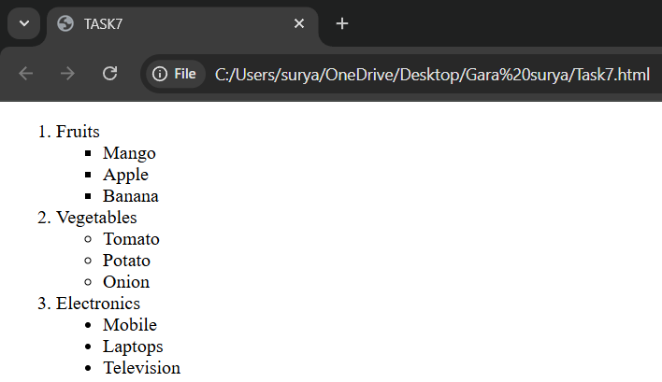

**7**

# TASK-8

**Title: Create an ordered list of your semester subjects. Use roman numerals for list markers. Start the numbering from IV using the start attribute**

**Source code:**

<!DOCTYPE html>

<html>

<head>

<title>TASK8</title>

</head>

<body>

<ol type="I" start="4">

<li>Web Interface Designing Technologies</li>

<li>Web Applications Development using PHP & MYSQL</li>

<li>Internet of Things</li>

<li>Application Development using Python</li>

<li>Python Programming</li>

<li>Data Analytics Methods</li>

</ol>

</body>

</html>

**Output:**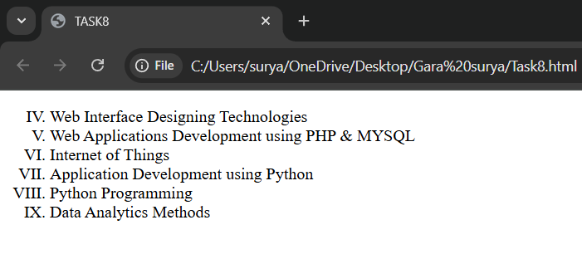

**8**

# 

# TASK-9

**Title: Create a student marks table using HTML table tags. contains: Name, Subject, Marks, Grade**

**Source code:wowor**

<!DOCTYPE html>

<html>

<head><title>TASK9</title></head>

<style>

table,th,td

{

border-color: Blue;

border-collapse: collapse;

}

table

{

width: 100%;

}

</style>

<body>

<table border="4">

<tr>

<th>Name</th>

<th>Subject</th>

<th>Marks</th>

<th>Grade</th>

</tr>

<tr>

<td>A</td>

<td>Maths</td>

<td>86</td>

<td>A</td>

</tr>

<tr>

<td>B</td>

<td>Chemistry</td>

<td>75</td>

<td>B</td>

</tr>

</table>

</body>

</html>

**Output:**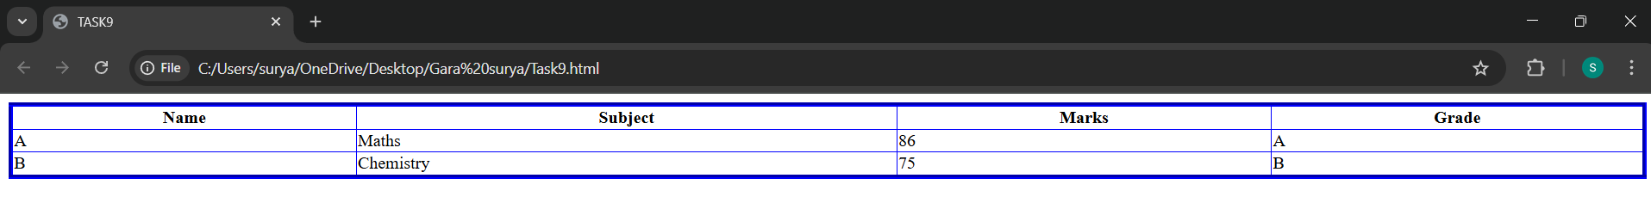

**9**

# TASK-10

**Title: Create a webpage that displays two images using the <img> tag.One image should be sized to 300x300pxThe other image should be 500x400px**

**Source code:**

<!DOCTYPE html>

<html>

<head><title>TASK10</title></head>

<body>

<img src="Tree_img.JPG" alt="Tree image" height="300px" , width="300px">

<img src="Mahesh Babu.JPG" alt="Mahesh image" height="300px" , width="300px" >

</body>

</html>

**Output:**

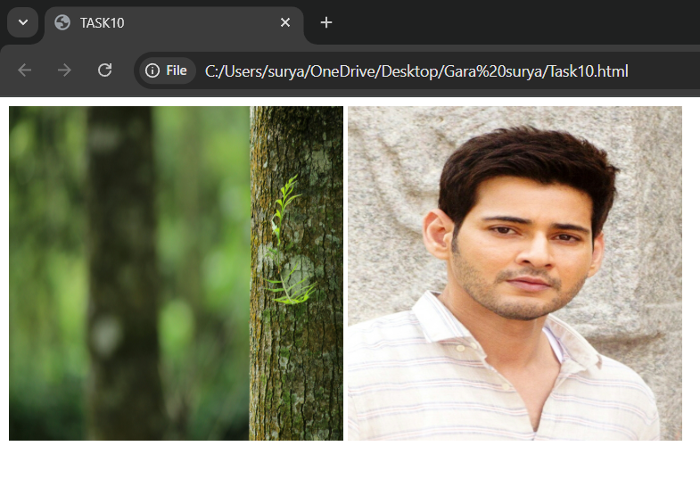

**10**

# TASK-11

**Title: Create a multimedia demo page using HTML. Embed a video using the <video> tag with controls, height, and width attributes Embed an audio file using the <audio> tag with the controls attribute**

**Source code:**

<!DOCTYPE html>

<html>

<head><title>TASK11</title></head>

<body>

<iframe width="560" height="315"

src="https://[www.youtube.com/embed/5nKpApXuM1g?si=JYcFKxOyRfpqKNRy"](http://www.youtube.com/embed/5nKpApXuM1g?si=JYcFKxOyRfpqKNRy)

title="YouTube video player" frameborder="0" allow="accelerometer; autoplay; clipboard-write; encrypted-media;

gyroscope; picture-in-picture;

web-share" referrerpolicy="strict-origin-when-cross-origin" allowfullscreen></iframe>

<audio src="Ranjhaan.mp3" controls></audio>

</body>

</html>

**Output:**

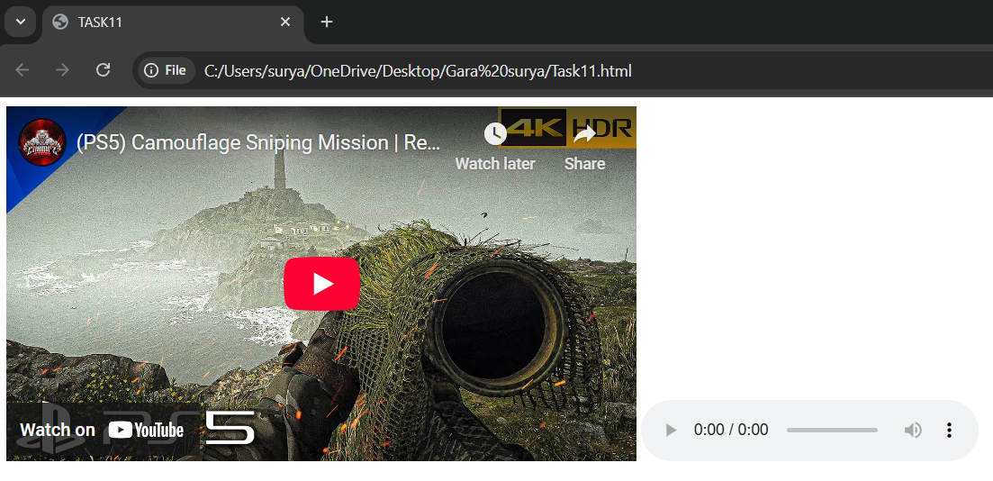

**11**

# TASK-12

**Title: Create a styled section using the <div> tag. The <div> should contain: A heading titled "Notification". A paragraph with any custom message. Add a border and padd padding using inline styles**

**Source code:**

<!DOCTYPE html>

<html>

<head><title>TASK12</title></head>

<style>

div{

background-color:Blue; width: 500px;

height: 500px; border: dashed;

}

p{

padding: 10px;

}

h1{

padding: 20px;

}

</style>

<body>

<div >

<h1>Notification</h1><br>

<p >This page was styled.</p>

</div>

</body>

</html>

**Output:**

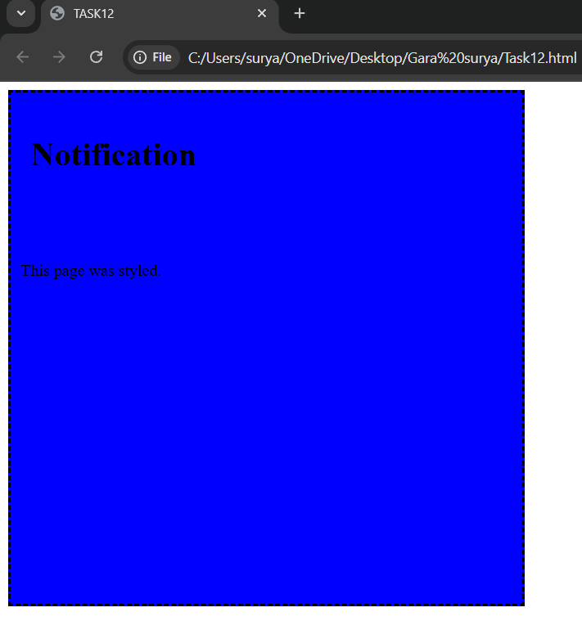

**12**

# TASK-13

**Title: Create a scrolling marquee using the <marquee> tag.. Add a scrolling text message from left to right. Add a marquee with an image scrolling vertically (either up or down)**

**Source code:**

<!DOCTYPE html>

<html>

<head><title>TASK13</title></head>

<body>

<marquee direction="right">This is Task 13.</marquee>

<marquee direction="up" width="50%" height="200px"><img src="Wallpaper.jpg" width="300px" height="300px"></marquee>

</body>

</html>

**Output:**

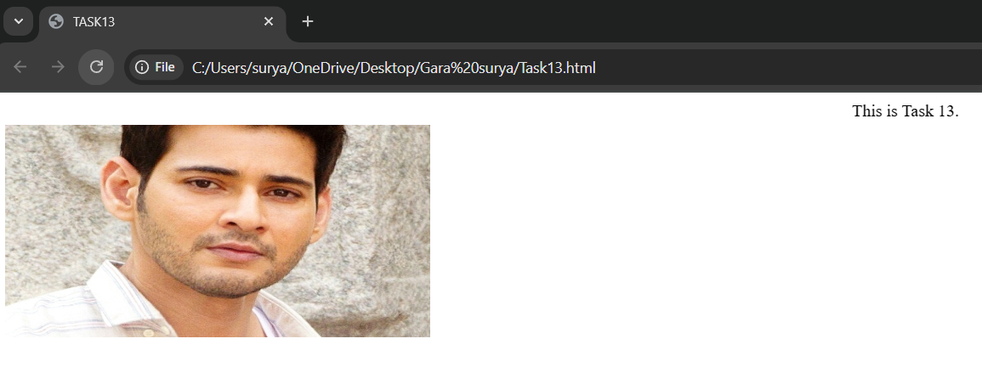

**13**

# TASK-14

**Title: Create a web page with a background image. Use the background attribute in the**

**<body> tag. Add a short paragraph over the background image describing it Source code:**

<!DOCTYPE html>

<html>

<head><title>TASK14</title></head>

<style>

body{

background-repeat: no-repeat; background-size: 100%;

}

p{

color: white;

}

</style>

<body background="Tree_img.jpg"></body>

<p>This is an Background Image.</p>

</html>

**Output:**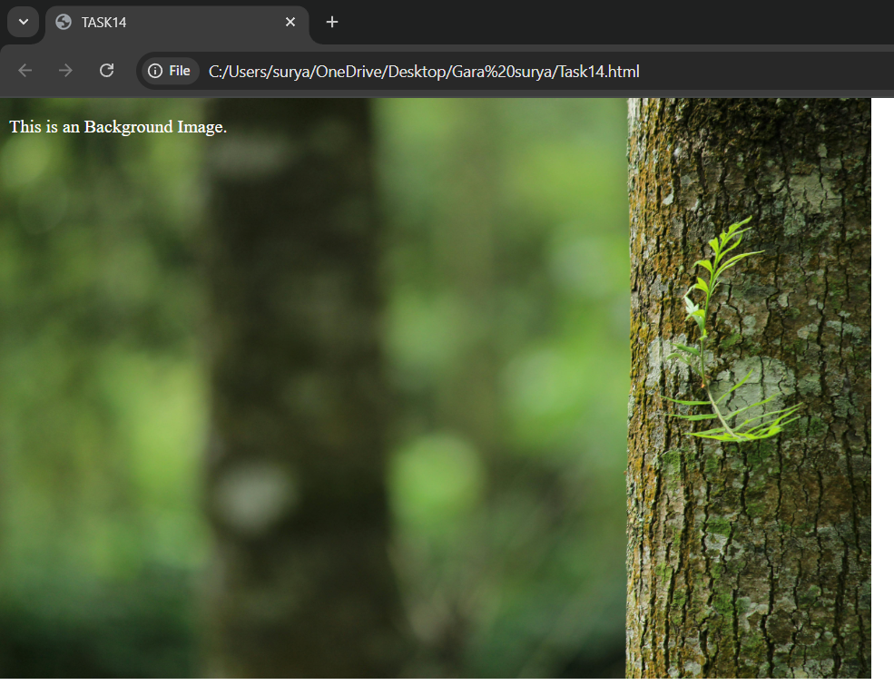

**14**

# TASK-15

**Title: Create a Student Registration Form Design a simple registration form with the**

**following fields: Full Name (Text Input), Email (Text Input), Gender (Radio Buttons: Male,**

**Female, Other). Courses Interested (Checkboxes: C, Java, Python, HTML). Location (Dropdown: Hyderabad, Vizag, Vijayawada). About Yourself (Textarea) About Yourself**

**(Textarea). A link at the bottom that says: “Already registered? Click here toA link at the bottom that says: “Already registered? Click here to login”**

**Source code:**

<!DOCTYPE html>

<html>

<head>

<title>TASK15</title>

</head>

<body>

<form>

<label for="name">Name:<input type="text" id="name" name="name"></label><br><br>

<label for="mail">Email:<input type="text" id="name" name="mail"></label><br><br>

<p><strong>Select your gender!</strong></p>

<input type="radio" id="male" name="gender" value="male">

<label for="male">Male</label><br>

<input type="radio" id="female" name="gender" value="female">

<label for="female">Female</label><br>

<input type="radio" id="others" name="gender" value="others">

<label for="others">Prefer not to say</label><br>

<p><strong>Select your Courses you want!</strong></p>

<input type="checkbox" id="c" name="c" value="C-Programming">

<label for="c">C-Programming</label><br>

<input type="checkbox" id="java" name="java" value="Java">

<label for="java">Java</label><br>

<input type="checkbox" id="python" name="python" value="Python">

<label for="python">Python</label><br>

<input type="checkbox" id="html" name="html" value="Html">

<label for="html">HTML</label><br><br>

<label for="loc">Location</label>

<select id="loc" name="location">

<option value="Hyderabad">Hyderabad</option>

<option value="Vizag">Vizag</option>

<option value="Vijayawada">Vijayawada</option>

</select><br><br>

<label for="text">About Yourself</label>

<textarea id="text" name="yourdata:"rows="3" cols="30"></textarea><br><br>

<a href="#">Already registered? click here to login</a><br><br>

<input type="submit" value="submit">

</form>

</body>

</html>

**Output:**

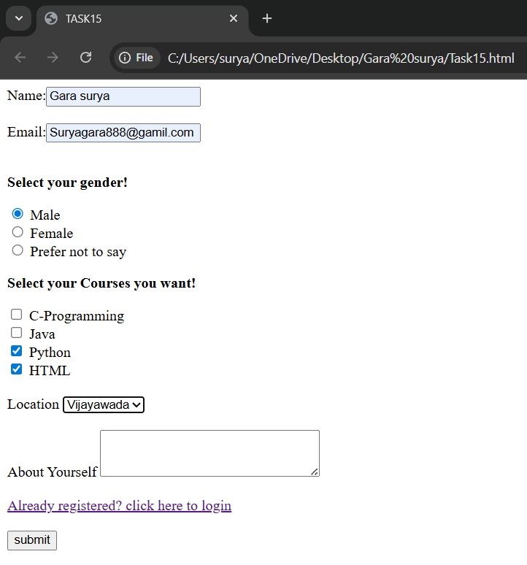

**15**

# TASK-16

**Title: Online Course Enrollment Page. Instructions: Create an online course enrollment**

**page: Title of the page should be centered and prominentAdd an introductory paragraph, Include an image related to online learning, Form inputs: o Student Name o Age o Select your course (at least 4 options. Choose your learning mode (Online, Offline,**

**Hybrid),Checkbox for: “I agree to the terms and conditions”,Include a text area for additional comments**

**Source code:**

<!DOCTYPE html>

<html>

<head>

<title>TASK16</title>

</head>

<style> h1{

text-align: center;

}

</style>

<body>

<h1>Online Courses</h1>

<p>Online learning unlocks a world of possibilities, transforming education with its

flexibility and accessibility. This paradigm shift allows students to learn at their own pace,

from anywhere, and in a manner that suits their individual needs. With readily available resources, engaging content,

and personalized learning pathways, online courses empower learners to master new skills, explore their passions, and achieve their academic and professional goals.

</p><br>

<img src="online.png" width="900px" height="400px"><br><br>

<form>

Student Name:<input type="text" id="name" name="name"/>

<label for="name"></label><br><br>

Age:<input type="number" id="age" name="age"/>

<labeL for="age"></labeL><br><br>

<label for="course">Select Your Course</label>

<select id="course" name="course">

<option value="C-Language">C-Language</option>

<option value="Java">Java</option>

<option value="HTML">HTML</option>

<option value="Python">Python</option>

</select><br><br>

Select Your Learning Mode:

<input type="radio" name="radio1" id="off" >

<label for="off">Ofline</label>

<input type="radio" name="radio1" id="on">

<label for="on">Online</label>

<input type="radio" name="radio1" id="hyb">

<label for="hyb">Hybrid</label><br><br>

<input type="checkbox" name="check" id="check">

<label for="check">"I agree to the terms and conditions"</label><br><br>

Any Comments:<textarea cols="16" rows="2"></textarea><br><br>

<button>Submit</button>

</form>

</body>

</html>

**Output:**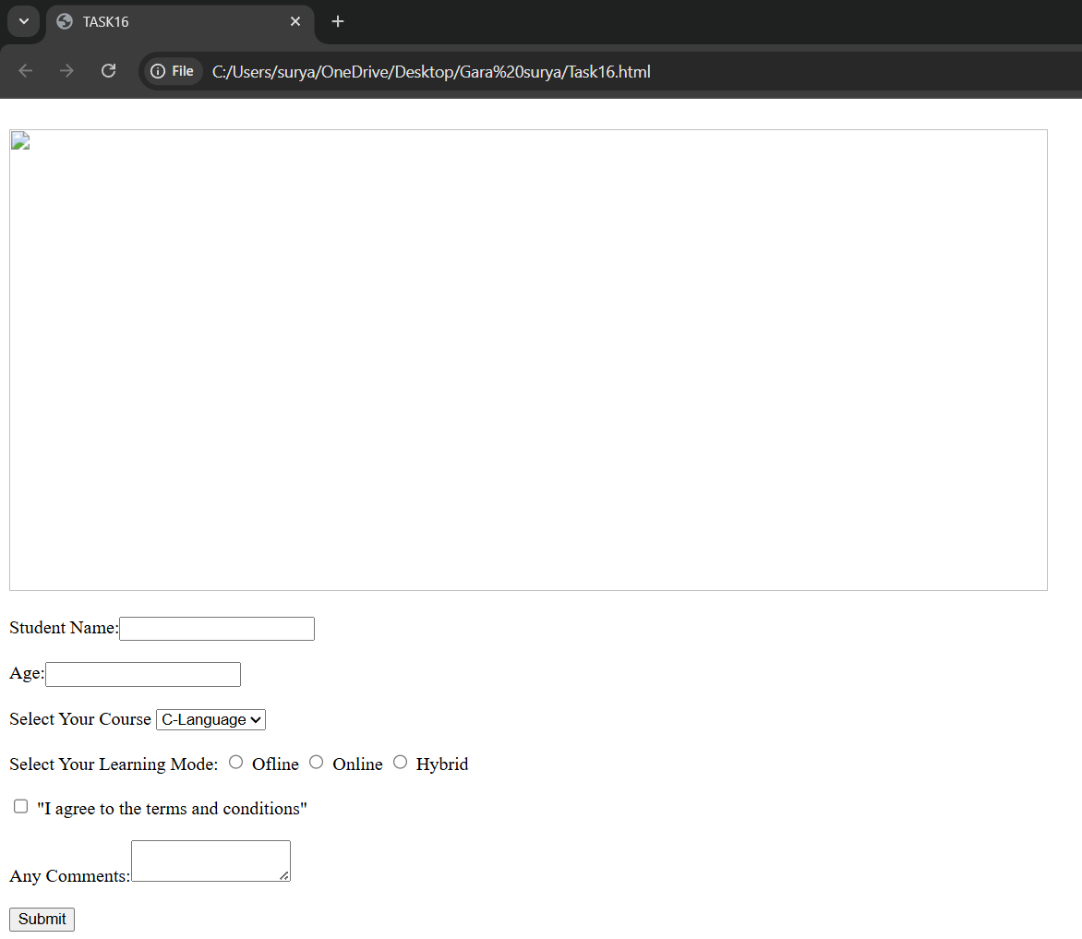

**16**

**Task-17**

**Title : Create a feedback form with radio buttons, checkboxes, dropdown,** **extarea, submit button, and home link.**

**Source code:**

**<!DOCTYPE html>**

**<html>**

**<head>**

**<title>Feedback Form</title>**

**<style>**

**body {**

**font-family: Arial, sans-serif;**

**margin: 40px;**

**background-color: #f2f2f2;**

**}**

**h2 {**

**text-align: center;**

**}**

**form {**

**background-color: #fff;**

**padding: 25px;**

**border-radius: 10px;**

**width: 400px;**

**margin: auto;**

**box-shadow: 0 0 10px rgba(0,0,0,0.2);**

**}**

**label {**

**display: block;**

**margin-top: 15px;**

**font-weight: bold;**

**}**

**textarea, select {**

**width: 100%;**

**padding: 8px;**

**margin-top: 5px;**

**border-radius: 5px;**

**border: 1px solid #ccc;**

**}**

**input[type="submit"] {**

**margin-top: 20px;**

**background-color: #4CAF50;**

**color: white;**

**padding: 10px;**

**width: 100%;**

**border: none;**

**border-radius: 5px;**

**cursor: pointer;**

**font-size: 16px;**

**}**

**a {**

**display: block;**

**text-align: center;**

**margin-top: 15px;**

**color: #007BFF;**

**text-decoration: none;**

**}**

**a:hover {**

**text-decoration: underline;**

**}**

**</style>**

**</head>**

**<body>**

**<h2>Feedback Form</h2>**

**<form action="#" method="post">**

**<label>How would you rate our service?</label>**

**<input type="radio" name="rating" value="excellent"> Excellent<br>**

**<input type="radio" name="rating" value="good"> Good<br>**

**<input type="radio" name="rating" value="average"> Average<br>**

**<input type="radio" name="rating" value="poor"> Poor<br>**

**<label>What did you like? (Check all that apply)</label>**

**<input type="checkbox" name="likes" value="design"> Design<br>**

**<input type="checkbox" name="likes" value="usability"> Usability<br>**

**<input type="checkbox" name="likes" value="performance"> Performance<br>**

**<input type="checkbox" name="likes" value="support"> Support<br>**

**<label>How did you hear about us?</label>**

**<select name="source">**

**<option value="google">Google</option>**

**<option value="friend">Friend</option>**

**<option value="social">Social Media</option>**

**<option value="other">Other</option>**

**</select>**

**<label>Additional Comments</label>**

**<textarea name="comments" rows="5" placeholder="Your feedback here..."></textarea>**

**<input type="submit" value="Submit Feedback">**

**<a href="index.html">Go to Home</a>**

**</form>**

**</body>**

**</html>**

**Output:**

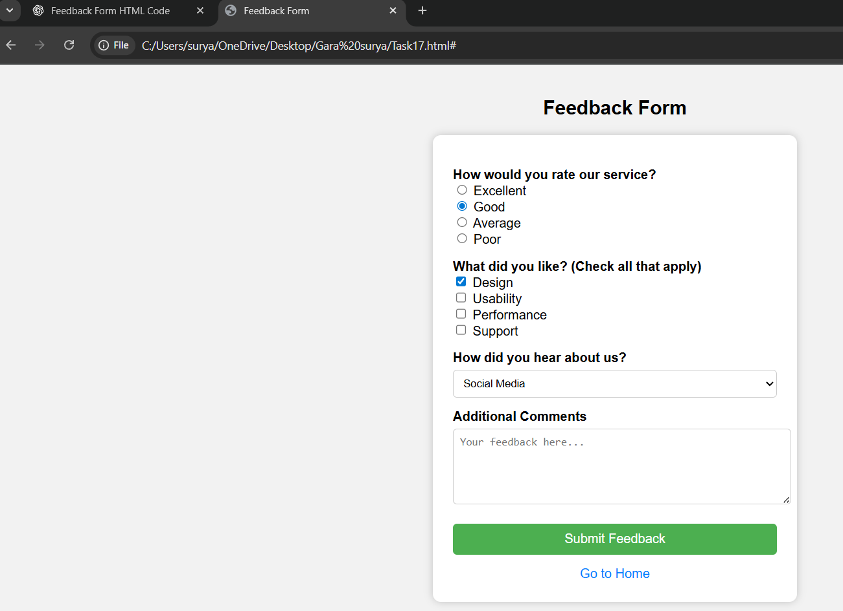

**17**

**Task-18**

**Title:** **College event signup page with scrolling title, video/audio, event table, and registration form.**

**Source code:**

**<!DOCTYPE html>**

**<html>**

**<head>**

**<title>College Event Signup</title>**

**<style>**

**body {**

**font-family: Arial, sans-serif;**

**background-color: #eef2f3;**

**margin: 0;**

**padding: 0;**

**}**

**marquee {**

**font-size: 24px;**

**background-color: #333;**

**color: #fff;**

**padding: 15px 0;**

**}**

**.container {**

**max-width: 800px;**

**margin: 30px auto;**

**padding: 20px;**

**background-color: white;**

**border-radius: 10px;**

**box-shadow: 0 0 10px rgba(0,0,0,0.2);**

**}**

**h2 {**

**text-align: center;**

**color: #333;**

**}**

**table {**

**width: 100%;**

**border-collapse: collapse;**

**margin: 20px 0;**

**}**

**th, td {**

**padding: 10px;**

**border: 1px solid #ccc;**

**text-align: center;**

**}**

**video, audio {**

**display: block;**

**margin: 20px auto;**

**}**

**form label {**

**display: block;**

**margin-top: 15px;**

**font-weight: bold;**

**}**

**input, select, textarea {**

**width: 100%;**

**padding: 8px;**

**margin-top: 5px;**

**border: 1px solid #ccc;**

**border-radius: 5px;**

**}**

**input[type="submit"] {**

**background-color: #28a745;**

**color: white;**

**font-size: 16px;**

**cursor: pointer;**

**margin-top: 20px;**

**}**

**</style>**

**</head>**

**<body>**

**<marquee behavior="scroll" direction="left">🎉 Welcome to the Annual College Event – Register Now! 🎉</marquee>**

**<div class="container">**

**<h2>College Event Details</h2>**

**<!-- Video -->**

**<video width="100%" controls>**

**<source src="event_promo.mp4" type="video/mp4">**

**Your browser does not support the video tag.**

**</video>**

**<!-- Audio -->**

**<audio controls autoplay>**

**<source src="event_theme.mp3" type="audio/mpeg">**

**Your browser does not support the audio element.**

**</audio>**

**<!-- Event Table -->**

**<table>**

**<thead>**

**<tr>**

**<th>Event</th>**

**<th>Date</th>**

**<th>Time</th>**

**<th>Location</th>**

**</tr>**

**</thead>**

**<tbody>**

**<tr>**

**<td>Inauguration Ceremony</td>**

**<td>Aug 10, 2025</td>**

**<td>10:00 AM</td>**

**<td>Main Auditorium</td>**

**</tr>**

**<tr>**

**<td>Cultural Fest</td>**

**<td>Aug 11, 2025</td>**

**<td>5:00 PM</td>**

**<td>Open Grounds</td>**

**</tr>**

**<tr>**

**<td>Technical Quiz</td>**

**<td>Aug 12, 2025</td>**

**<td>11:00 AM</td>**

**<td>Seminar Hall</td>**

**</tr>**

**</tbody>**

**</table>**

**<!-- Registration Form -->**

**<h2>Event Registration Form</h2>**

**<form action="#" method="post">**

**<label for="name">Full Name:</label>**

**<input type="text" id="name" name="name" required>**

**<label for="email">Email Address:</label>**

**<input type="email" id="email" name="email" required>**

**<label for="department">Department:</label>**

**<select id="department" name="department">**

**<option value="CSE">Computer Science</option>**

**<option value="ECE">Electronics</option>**

**<option value="ME">Mechanical</option>**

**<option value="CE">Civil</option>**

**</select>**

**<label for="event">Select Event:</label>**

**<select id="event" name="event">**

**<option value="inauguration">Inauguration Ceremony</option>**

**<option value="cultural">Cultural Fest</option>**

**<option value="quiz">Technical Quiz</option>**

**</select>**

**<label for="comments">Comments:</label>**

**<textarea id="comments" name="comments" rows="4" placeholder="Any special request or comment..."></textarea>**

**<input type="submit" value="Register Now">**

**</form>**

**</div>**

**</body>**

**</html>**

**Output:**

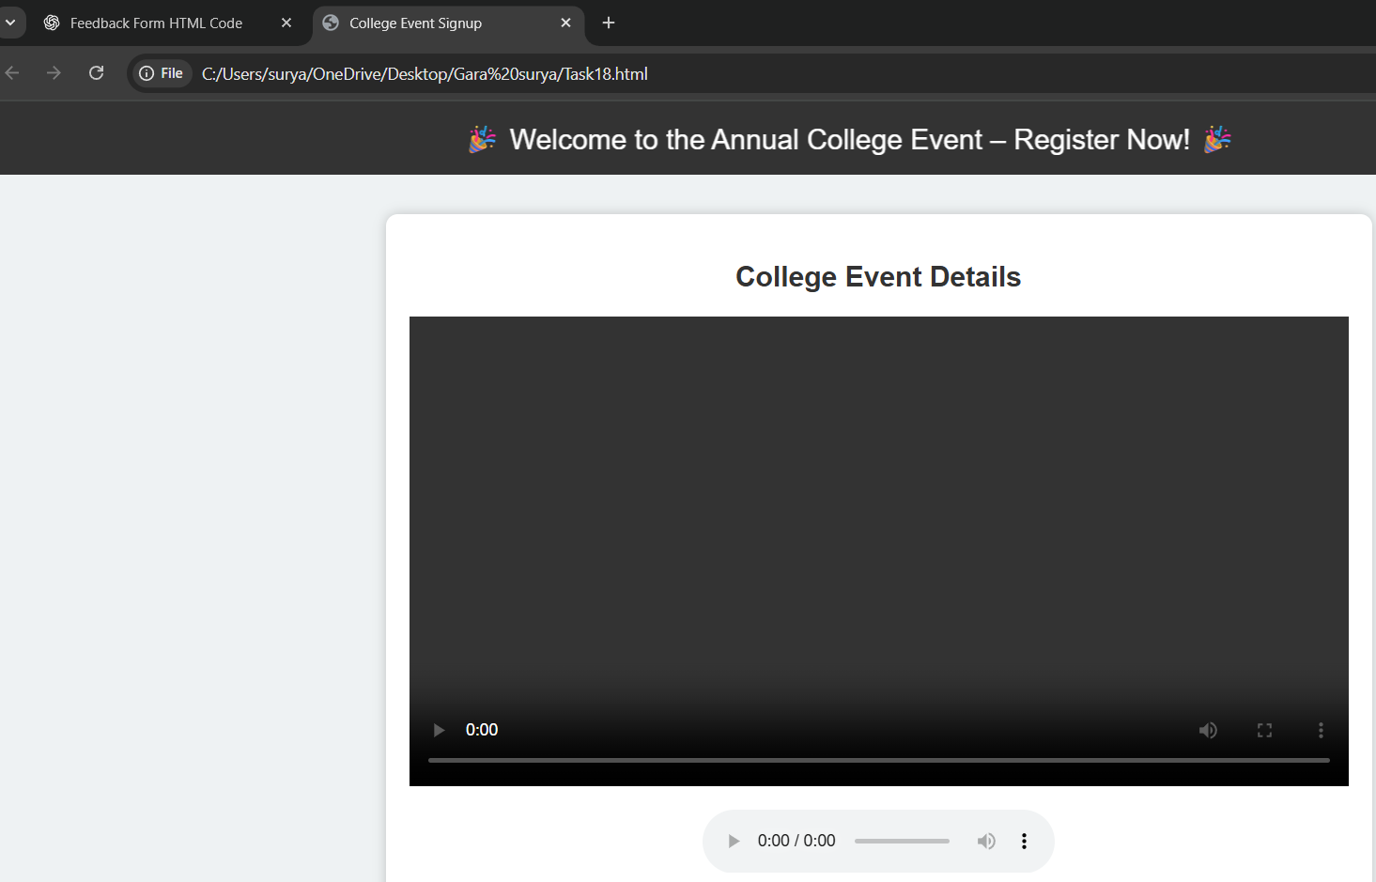

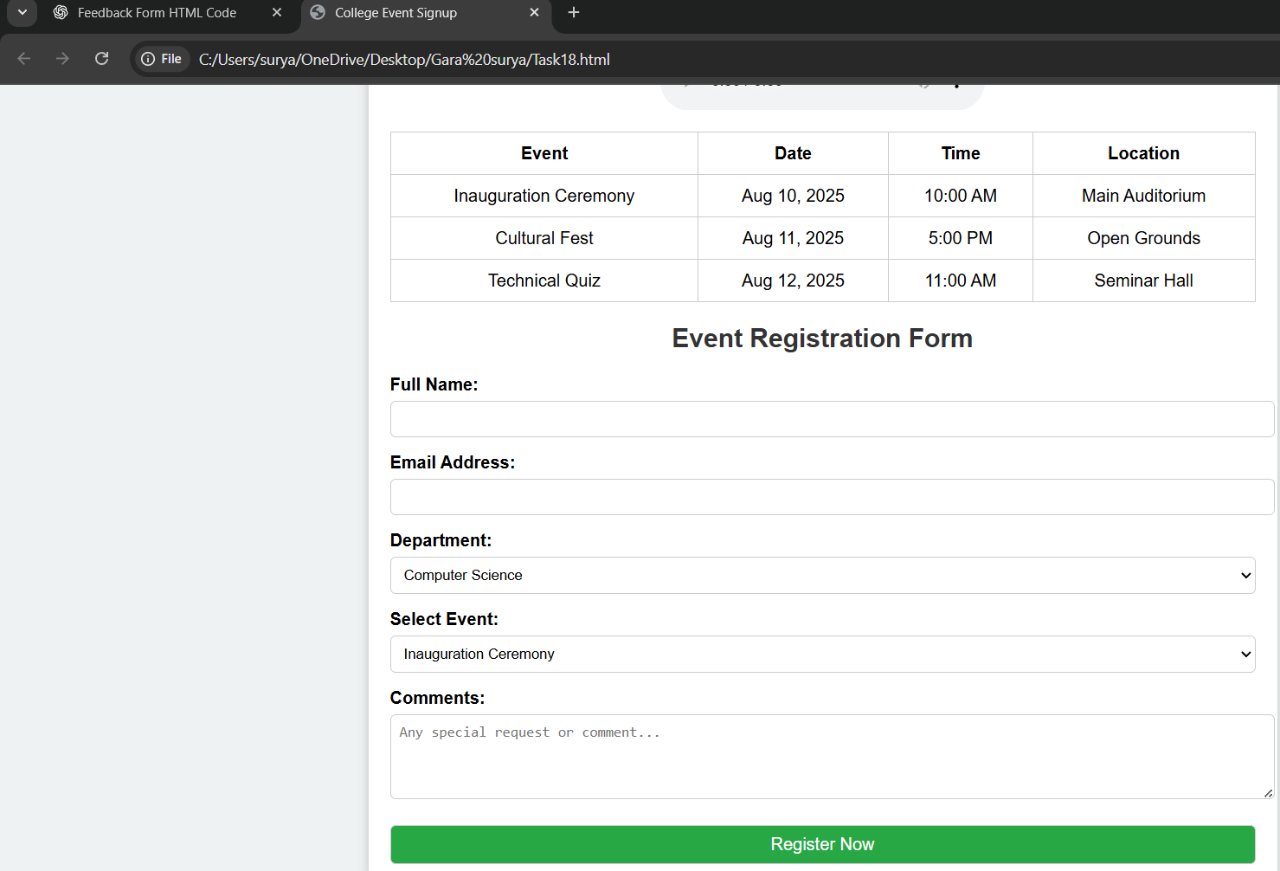

**18**

**Task-19**

**Title:** **Job application form with heading, paragraph, inputs, skills, resume label, and link to company page.**

**Source code:**

**<!DOCTYPE html>**

**<html>**

**<head>**

**<title>Job Application Form</title>**

**<style>**

**body {**

**font-family: Arial, sans-serif;**

**background-color: #f4f6f8;**

**padding: 30px;**

**}**

**.form-container {**

**background-color: white;**

**padding: 25px;**

**border-radius: 10px;**

**max-width: 600px;**

**margin: auto;**

**box-shadow: 0 0 10px rgba(0,0,0,0.1);**

**}**

**h2 {**

**text-align: center;**

**color: #333;**

**}**

**p {**

**text-align: center;**

**color: #666;**

**}**

**label {**

**display: block;**

**margin-top: 15px;**

**font-weight: bold;**

**}**

**input[type="text"],**

**input[type="email"],**

**input[type="tel"],**

**textarea,**

**input[type="file"] {**

**width: 100%;**

**padding: 8px;**

**margin-top: 5px;**

**border: 1px solid #ccc;**

**border-radius: 5px;**

**}**

**.skills {**

**margin-top: 10px;**

**}**

**.skills input {**

**margin-right: 8px;**

**}**

**input[type="submit"] {**

**margin-top: 20px;**

**background-color: #007BFF;**

**color: white;**

**padding: 10px;**

**border: none;**

**width: 100%;**

**font-size: 16px;**

**border-radius: 5px;**

**cursor: pointer;**

**}**

**a {**

**display: block;**

**text-align: center;**

**margin-top: 20px;**

**color: #007BFF;**

**text-decoration: none;**

**}**

**a:hover {**

**text-decoration: underline;**

**}**

**</style>**

**</head>**

**<body>**

**<div class="form-container">**

**<h2>Job Application Form</h2>**

**<p>Please fill out the form below to apply for a position at our company.</p>**

**<form action="#" method="post" enctype="multipart/form-data">**

**<label for="name">Full Name:</label>**

**<input type="text" id="name" name="name" required>**

**<label for="email">Email Address:</label>**

**<input type="email" id="email" name="email" required>**

**<label for="phone">Phone Number:</label>**

**<input type="tel" id="phone" name="phone" required>**

**<label>Skills:</label>**

**<div class="skills">**

**<input type="checkbox" id="html" name="skills" value="HTML">**

**<label for="html">HTML</label><br>**

**<input type="checkbox" id="css" name="skills" value="CSS">**

**<label for="css">CSS</label><br>**

**<input type="checkbox" id="js" name="skills" value="JavaScript">**

**<label for="js">JavaScript</label><br>**

**<input type="checkbox" id="python" name="skills" value="Python">**

**<label for="python">Python</label><br>**

**</div>**

**<label for="resume">Upload Your Resume:</label>**

**<input type="file" id="resume" name="resume" accept=".pdf,.doc,.docx" required>**

**<input type="submit" value="Submit Application">**

**<a href="https://www.companywebsite.com" target="_blank">Visit Our Company Page</a>**

**</form>**

**</div>**

**</body>**

**</html>**

**Output:**

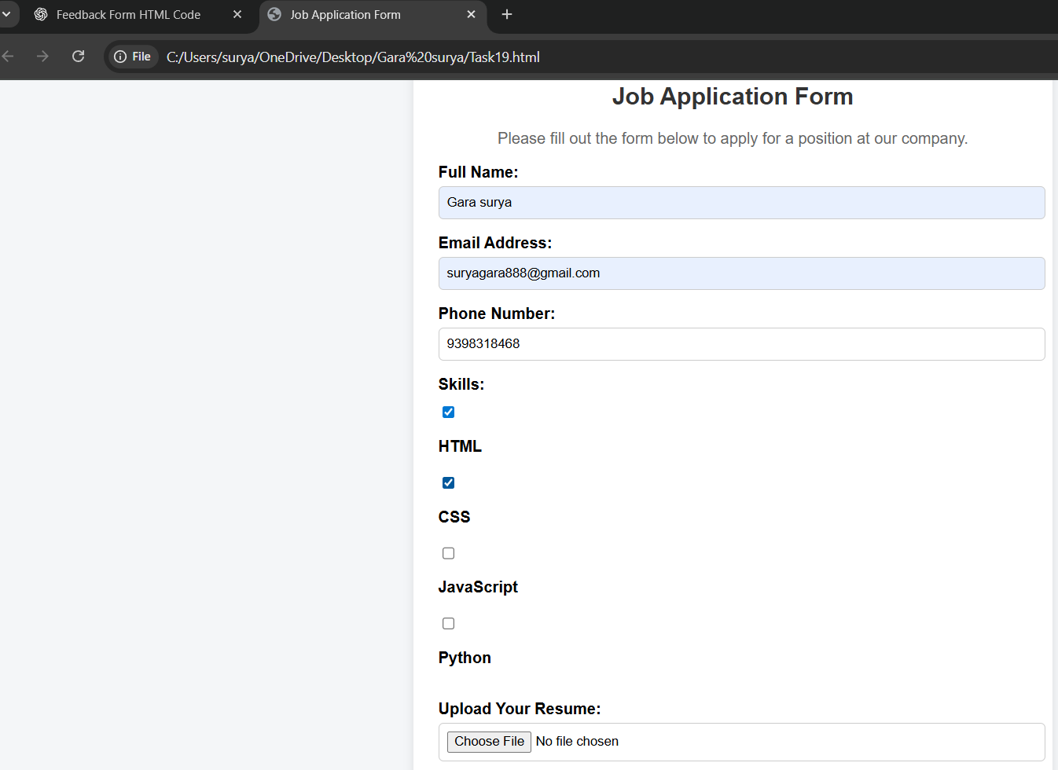

**19**

**Task-20**

**Title:** **personal homepage with name, page links, background info, image and description.**

**Source code:**

**<!DOCTYPE html>**

**<html>**

**<head>**

**<title>My Personal Homepage</title>**

**<style>**

**body {**

**font-family: Arial, sans-serif;**

**background-color: #e8f0fe;**

**margin: 0;**

**padding: 0;**

**}**

**header {**

**background-color: #1a73e8;**

**color: white;**

**padding: 20px 0;**

**text-align: center;**

**}**

**nav {**

**background-color: #f1f1f1;**

**padding: 10px;**

**text-align: center;**

**}**

**nav a {**

**margin: 0 15px;**

**color: #1a73e8;**

**text-decoration: none;**

**font-weight: bold;**

**}**

**nav a:hover {**

**text-decoration: underline;**

**}**

**.container {**

**max-width: 900px;**

**margin: 30px auto;**

**background-color: white;**

**padding: 25px;**

**border-radius: 10px;**

**box-shadow: 0 0 10px rgba(0,0,0,0.1);**

**}**

**.profile {**

**display: flex;**

**flex-wrap: wrap;**

**align-items: center;**

**}**

**.profile img {**

**border-radius: 50%;**

**width: 200px;**

**height: 200px;**

**margin-right: 30px;**

**}**

**.bio {**

**flex: 1;**

**}**

**.bio h3 {**

**margin-top: 0;**

**color: #333;**

**}**

**footer {**

**text-align: center;**

**padding: 15px;**

**background-color: #f1f1f1;**

**color: #777;**

**margin-top: 30px;**

**}**

**</style>**

**</head>**

**<body>**

**<header>**

**<h1>Gara Surya</h1>**

**<p>Welcome to my personal homepage!</p>**

**</header>**

**<nav>**

**<a href="#about">About Me</a>**

**<a href="#projects">Projects</a>**

**<a href="#contact">Contact</a>**

**</nav>**

**<div class="container" id="about">**

**<div class="profile">**

**<img src="profile.jpg" alt="My Photo">**

**<div class="bio">**

**<h3>Hi, I'm Surya!</h3>**

**<p>I am a passionate web developer and computer science student. I love learning new technologies, building creative projects, and sharing knowledge with others. My interests include front-end development, databases, and open-source contributions.</p>**

**</div>**

**</div>**

**</div>**

**<div class="container" id="projects">**

**<h2>Projects</h2>**

**<ul>**

**<li><strong>Portfolio Website:</strong> A personal portfolio built using HTML, CSS, and JavaScript.</li>**

**<li><strong>Student Management System:</strong> Web app with MongoDB and Node.js.</li>**

**<li><strong>Weather App:</strong> Uses API to fetch real-time weather data.</li>**

**</ul>**

**</div>**

**<div class="container" id="contact">**

**<h2>Contact</h2>**

**<p>You can reach me at: <strong>surya@example.com</strong></p>**

**<p>Or follow me on:**

**<a href="https://github.com/yourusername" target="_blank">GitHub</a>**

**<a href="https://linkedin.com/in/yourusername" target="_blank">LinkedIn</a>**

**</p>**

**</div>**

**<footer>**

**&copy; 2025 Gara Surya | All Rights Reserved**

**</footer>**

**</body>**

**</html>**

**Output:**

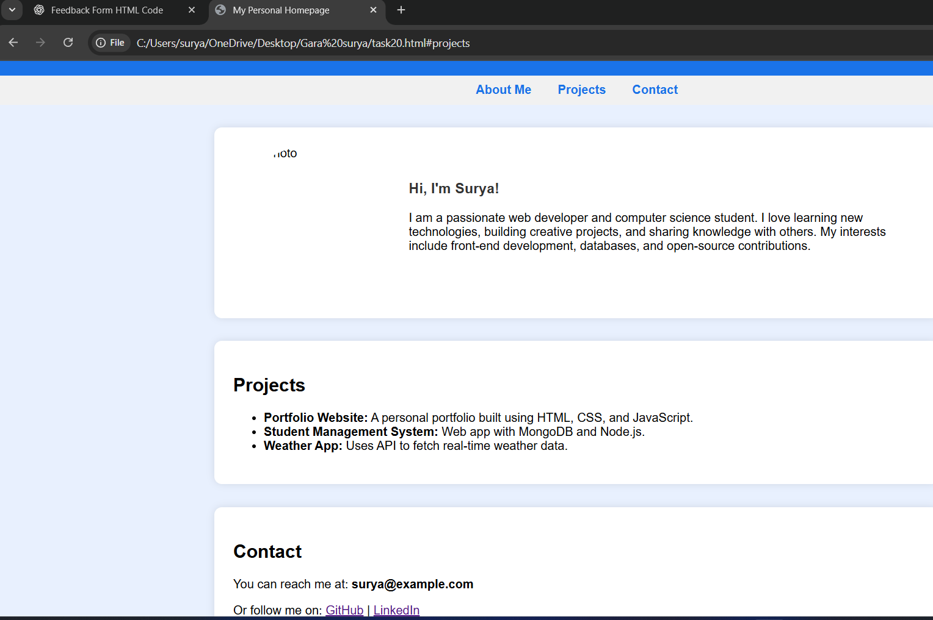

**20**

**Task-21**

**Title:** **Design a layout with two vertical panels: one showing a website, the other Wikipedia.**

**Source code:**

**<!DOCTYPE html>**

**<html>**

**<head>**

**<title>Two-Panel Viewer</title>**

**<style>**

**body {**

**margin: 0;**

**padding: 0;**

**height: 100vh;**

**display: flex;**

**font-family: Arial, sans-serif;**

**}**

**.panel {**

**flex: 1;**

**height: 100vh;**

**border: none;**

**}**

**.left {**

**border-right: 2px solid #ccc;**

**}**

**</style>**

**</head>**

**<body>**

**<!-- Left Panel: Website -->**

**<iframe class="panel left" src="https://example.com" title="Website View"></iframe>**

**<!-- Right Panel: Wikipedia -->**

**<iframe class="panel right" src="https://en.wikipedia.org/wiki/Main_Page" title="Wikipedia View"></iframe>**

**</body>**

**</html>**

**Output:**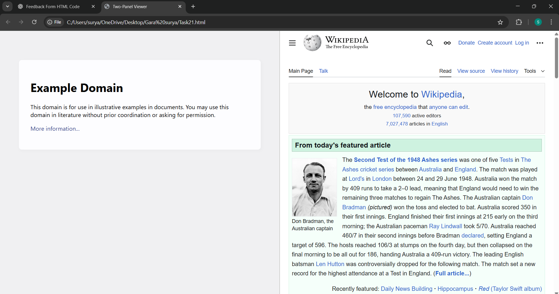

**21**

**Task-22**

**Title:** **Event registration form with gender radio buttons, interest checkboxes, city dropdown, comments, and buttons.**

**Source code:**

**<!DOCTYPE html>**

**<html>**

**<head>**

**<title>Event Registration Form</title>**

**<style>**

**body {**

**font-family: Arial, sans-serif;**

**background-color: #f4f6f8;**

**padding: 30px;**

**}**

**.form-container {**

**max-width: 600px;**

**margin: auto;**

**background-color: white;**

**padding: 25px;**

**border-radius: 10px;**

**box-shadow: 0 0 10px rgba(0,0,0,0.1);**

**}**

**h2 {**

**text-align: center;**

**color: #333;**

**}**

**label {**

**display: block;**

**margin-top: 15px;**

**font-weight: bold;**

**}**

**input[type="text"],**

**select,**

**textarea {**

**width: 100%;**

**padding: 8px;**

**margin-top: 5px;**

**border: 1px solid #ccc;**

**border-radius: 5px;**

**}**

**.gender, .interests {**

**margin-top: 10px;**

**}**

**.gender input,**

**.interests input {**

**margin-right: 8px;**

**}**

**.buttons {**

**margin-top: 20px;**

**text-align: center;**

**}**

**.buttons input {**

**padding: 10px 20px;**

**margin: 0 10px;**

**border: none;**

**border-radius: 5px;**

**font-size: 16px;**

**cursor: pointer;**

**}**

**.submit-btn {**

**background-color: #28a745;**

**color: white;**

**}**

**.reset-btn {**

**background-color: #dc3545;**

**color: white;**

**}**

**</style>**

**</head>**

**<body>**

**<div class="form-container">**

**<h2>Event Registration</h2>**

**<form action="#" method="post">**

**<label for="name">Full Name:</label>**

**<input type="text" id="name" name="name" required>**

**<!-- Gender -->**

**<label>Gender:</label>**

**<div class="gender">**

**<input type="radio" id="male" name="gender" value="Male">**

**<label for="male">Male</label>**

**<input type="radio" id="female" name="gender" value="Female">**

**<label for="female">Female</label>**

**<input type="radio" id="other" name="gender" value="Other">**

**<label for="other">Other</label>**

**</div>**

**<!-- Interests -->**

**<label>Interests:</label>**

**<div class="interests">**

**<input type="checkbox" id="tech" name="interests" value="Technology">**

**<label for="tech">Technology</label><br>**

**<input type="checkbox" id="music" name="interests" value="Music">**

**<label for="music">Music</label><br>**

**<input type="checkbox" id="sports" name="interests" value="Sports">**

**<label for="sports">Sports</label><br>**

**<input type="checkbox" id="art" name="interests" value="Art">**

**<label for="art">Art</label>**

**</div>**

**<!-- City Dropdown -->**

**<label for="city">City:</label>**

**<select id="city" name="city" required>**

**<option value="">-- Select City --</option>**

**<option value="Delhi">Delhi</option>**

**<option value="Mumbai">Mumbai</option>**

**<option value="Chennai">Chennai</option>**

**<option value="Bangalore">Bangalore</option>**

**</select>**

**<!-- Comments -->**

**<label for="comments">Additional Comments:</label>**

**<textarea id="comments" name="comments" rows="4" placeholder="Any special request or comment..."></textarea>**

**<!-- Buttons -->**

**<div class="buttons">**

**<input type="submit" class="submit-btn" value="Register">**

**<input type="reset" class="reset-btn" value="Reset">**

**</div>**

**</form>**

**</div>**

**</body>**

**</html>**

**Output:**

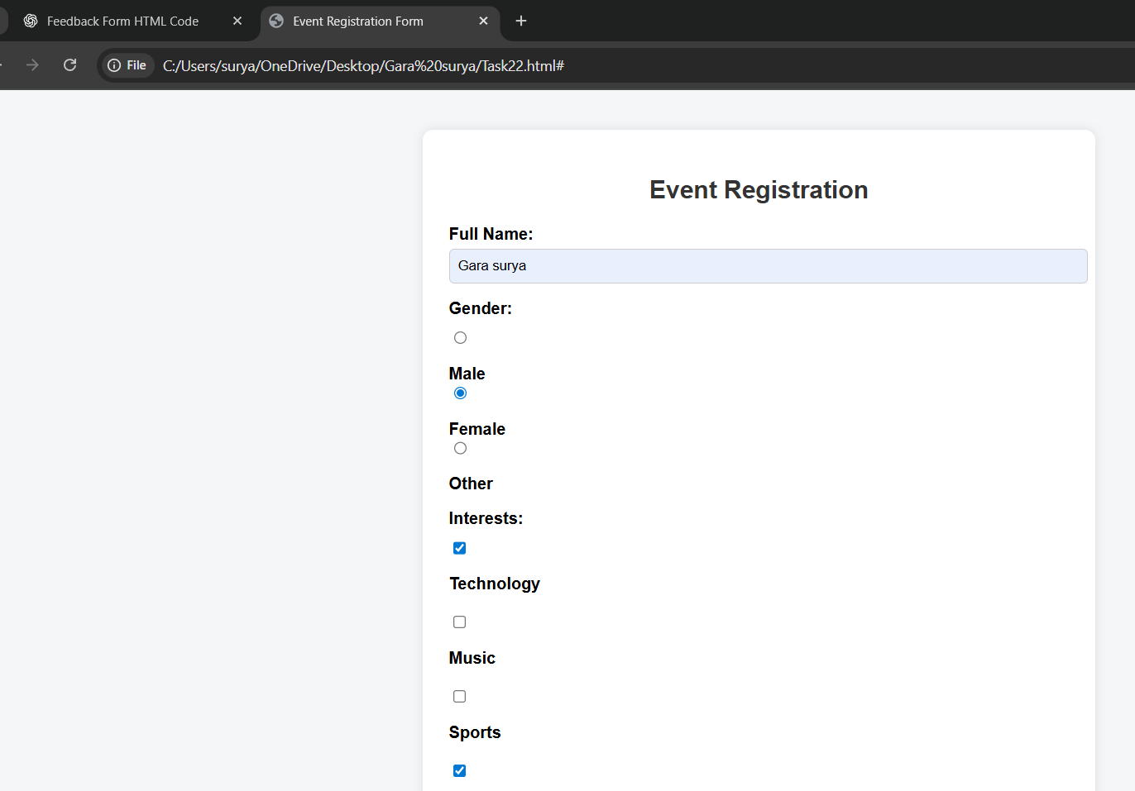

**22**

**Task-23**

**Title:** Single page layout with news, tips/ads, and footer info

**Source code:**

**<!DOCTYPE html>**

**<html>**

**<head>**

**<title>News and Tips Page</title>**

**<style>**

**body {**

**margin: 0;**

**font-family: Arial, sans-serif;**

**background-color: #f4f4f4;**

**}**

**header {**

**background-color: #007BFF;**

**color: white;**

**padding: 20px;**

**text-align: center;**

**}**

**.container {**

**display: flex;**

**flex-direction: row;**

**padding: 20px;**

**}**

**.news {**

**flex: 3;**

**background-color: #ffffff;**

**padding: 20px;**

**margin-right: 20px;**

**border-radius: 8px;**

**box-shadow: 0 0 8px rgba(0,0,0,0.1);**

**}**

**.tips {**

**flex: 1;**

**background-color: #fff8dc;**

**padding: 20px;**

**border-radius: 8px;**

**box-shadow: 0 0 8px rgba(0,0,0,0.1);**

**}**

**footer {**

**background-color: #333;**

**color: white;**

**text-align: center;**

**padding: 15px;**

**margin-top: 20px;**

**}**

**h2 {**

**color: #333;**

**}**

**ul {**

**padding-left: 20px;**

**}**

**.ad {**

**background-color: #ffefc4;**

**padding: 10px;**

**margin-top: 15px;**

**border-left: 4px solid #ffa500;**

**}**

**</style>**

**</head>**

**<body>**

**<header>**

**<h1>Daily Buzz</h1>**

**<p>Your one-stop for news, tips, and updates</p>**

**</header>**

**<div class="container">**

**<!-- News Section -->**

**<div class="news">**

**<h2>Latest News</h2>**

**<p><strong>Tech:</strong> AI continues to reshape industries in 2025, with startups booming in India and the US.</p>**

**<p><strong>Health:</strong> Experts recommend 30 minutes of walking daily to boost immunity.</p>**

**<p><strong>Sports:</strong> India defeats Australia in a thrilling final to lift the Champions Trophy.</p>**

**</div>**

**<!-- Tips/Ads Section -->**

**<div class="tips">**

**<h2>Quick Tips</h2>**

**<ul>**

**<li>Clear browser cache regularly for better speed.</li>**

**<li>Use strong passwords and enable 2FA.</li>**

**<li>Drink 2–3 liters of water a day.</li>**

**</ul>**

**<div class="ad">**

**<h3>Ad: Learn Web Development</h3>**

**<p>Join our online course and become a full-stack developer in 3 months!</p>**

**<a href="https://example.com" target="_blank">Sign Up Now</a>**

**</div>**

**</div>**

**</div>**

**<!-- Footer Section -->**

**<footer>**

**&copy; 2025 Daily Buzz | All Rights Reserved | Contact: info@dailybuzz.com**

**</footer>**

**</body>**

**</html>**

**Output:**

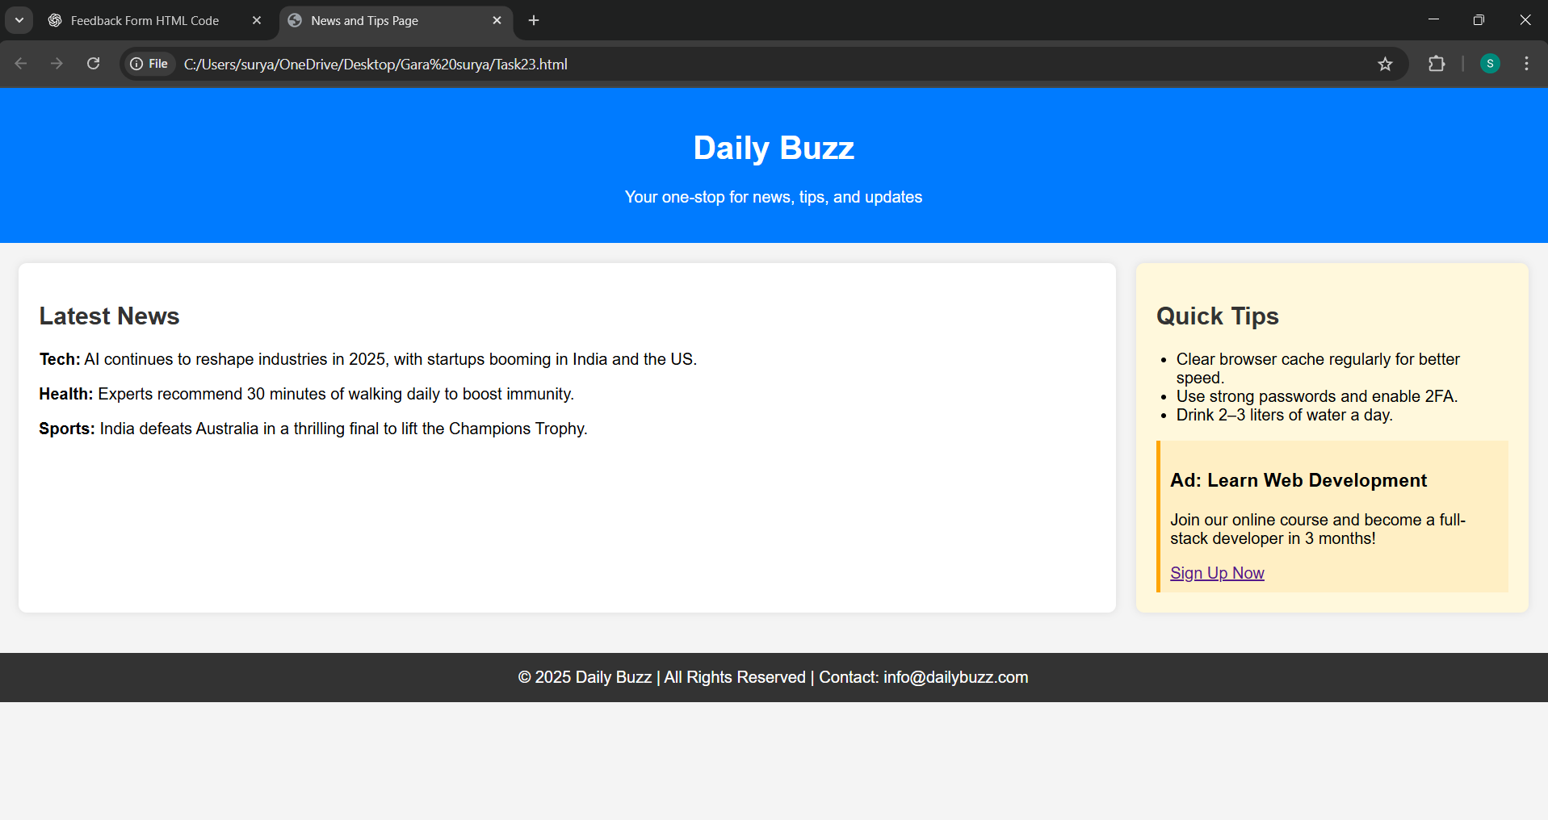

**23**

**Task-24**

**Title:** **Payment form grouping UPI, Card, and COD with radio buttons and label.**

**Source code:**

**<!DOCTYPE html>**

**<html>**

**<head>**

**<title>Payment Method Form</title>**

**<style>**

**body {**

**font-family: Arial, sans-serif;**

**background-color: #f4f6f8;**

**padding: 30px;**

**}**

**.form-container {**

**max-width: 500px;**

**margin: auto;**

**background-color: white;**

**padding: 25px;**

**border-radius: 10px;**

**box-shadow: 0 0 8px rgba(0,0,0,0.1);**

**}**

**h2 {**

**text-align: center;**

**color: #333;**

**}**

**fieldset {**

**border: 2px solid #ccc;**

**padding: 20px;**

**border-radius: 8px;**

**margin-top: 20px;**

**}**

**legend {**

**font-weight: bold;**

**padding: 0 10px;**

**color: #007BFF;**

**}**

**label {**

**display: block;**

**margin-top: 10px;**

**font-size: 16px;**

**}**

**input[type="radio"] {**

**margin-right: 10px;**

**}**

**.submit-btn {**

**margin-top: 20px;**

**background-color: #28a745;**

**color: white;**

**padding: 10px;**

**width: 100%;**

**font-size: 16px;**

**border: none;**

**border-radius: 5px;**

**cursor: pointer;**

**}**

**</style>**

**</head>**

**<body>**

**<div class="form-container">**

**<h2>Select Payment Method</h2>**

**<form action="#" method="post">**

**<fieldset>**

**<legend>Payment Options</legend>**

**<label>**

**<input type="radio" name="payment" value="UPI" required>**

**UPI (Google Pay, PhonePe, Paytm, etc.)**

**</label>**

**<label>**

**<input type="radio" name="payment" value="Card">**

**Credit/Debit Card**

**</label>**

**<label>**

**<input type="radio" name="payment" value="COD">**

**Cash on Delivery (COD)**

**</label>**

**</fieldset>**

**<input type="submit" class="submit-btn" value="Proceed to Pay">**

**</form>**

**</div>**

**</body>**

**</html>**

**Output:**

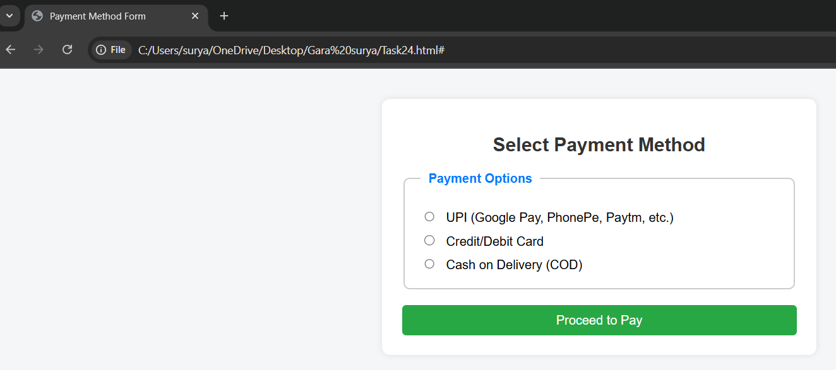

**24**

**Task-25**

**Title:** **Display a product offer showing original (struck) and discounted price, with underlined features.**

**Source code:**

**<!DOCTYPE html>**

**<html lang="en">**

**<head>**

**<meta charset="UTF-8">**

**<title>Product Offer</title>**

**<style>**

**.product-offer {**

**font-family: Arial, sans-serif;**

**max-width: 400px;**

**border: 1px solid #ddd;**

**padding: 15px;**

**margin: 20px;**

**border-radius: 8px;**

**background-color: #f9f9f9;**

**}**

**.product-title {**

**font-size: 1.5em;**

**margin-bottom: 10px;**

**}**

**.price {**

**margin-bottom: 10px;**

**}**

**.original-price {**

**text-decoration: line-through;**

**color: #888;**

**margin-right: 10px;**

**}**

**.discounted-price {**

**font-weight: bold;**

**color: #d32f2f;**

**font-size: 1.2em;**

**}**

**.features {**

**margin-top: 10px;**

**}**

**.features li {**

**text-decoration: underline;**

**margin-bottom: 5px;**

**}**

**</style>**

**</head>**

**<body>**

**<div class="product-offer">**

**<div class="product-title">Wireless Bluetooth Headphones</div>**

**<div class="price">**

**<span class="original-price">₹2,499</span>**

**<span class="discounted-price">₹1,499</span>**

**</div>**

**<ul class="features">**

**<li>Up to 20 hours battery life</li>**

**<li>Noise cancellation</li>**

**<li>Built-in microphone</li>**

**</ul>**

**</div>**

**</body>**

**</html>**

**Output:**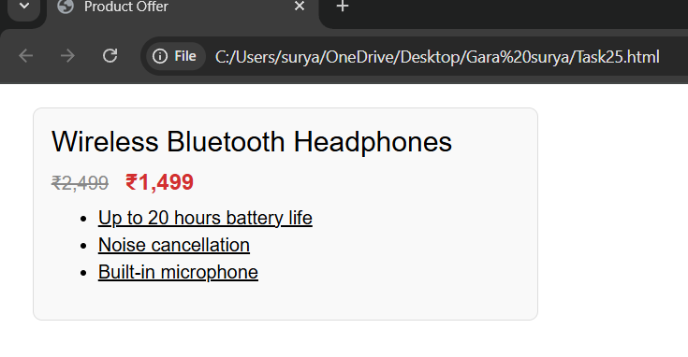

**25**

**Task-26**

**Title:** **Blog layout with title, nav, article, sidebar, and footer.**

**Source code:**

**<!DOCTYPE html>**

**<html lang="en">**

**<head>**

**<meta charset="UTF-8">**

**<meta name="viewport" content="width=device-width, initial-scale=1">**

**<title>Simple Blog Layout</title>**

**<style>**

**body {**

**margin: 0;**

**font-family: Arial, sans-serif;**

**line-height: 1.6;**

**}**

**header {**

**background: #333;**

**color: #fff;**

**padding: 1rem;**

**text-align: center;**

**}**

**nav {**

**background: #444;**

**color: white;**

**padding: 1rem;**

**text-align: center;**

**}**

**nav a {**

**color: white;**

**margin: 0 15px;**

**text-decoration: none;**

**}**

**.container {**

**display: flex;**

**flex-wrap: wrap;**

**margin: 1rem;**

**}**

**article {**

**flex: 3;**

**padding: 1rem;**

**background: #f4f4f4;**

**}**

**aside {**

**flex: 1;**

**padding: 1rem;**

**background: #e4e4e4;**

**}**

**footer {**

**background: #333;**

**color: #fff;**

**text-align: center;**

**padding: 1rem;**

**margin-top: 1rem;**

**}**

**@media (max-width: 768px) {**

**.container {**

**flex-direction: column;**

**}**

**}**

**</style>**

**</head>**

**<body>**

**<header>**

**<h1>My Blog</h1>**

**</header>**

**<nav>**

**<a href="#">Home</a>**

**<a href="#">Articles</a>**

**<a href="#">About</a>**

**<a href="#">Contact</a>**

**</nav>**

**<div class="container">**

**<article>**

**<h2>Blog Post Title</h2>**

**<p>This is the main content of the blog post. You can write your article here.</p>**

**</article>**

**<aside>**

**<h3>Sidebar</h3>**

**<p>Related posts, ads, or additional links can go here.</p>**

**</aside>**

**</div>**

**<footer>**

**<p>© 2025 My Blog. All rights reserved.</p>**

**</footer>**

**</body>**

**</html>**

**Output:**

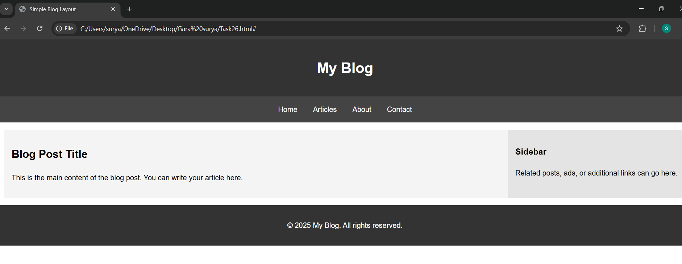

**26**

**Task-27**

**Title:** **Science/math article showing H₂O, a squared number, and a scientist quote.**

**Source code:**

**<!DOCTYPE html>**

**<html lang="en">**

**<head>**

**<meta charset="UTF-8">**

**<title>Exploring Science and Math</title>**

**<style>**

**body {**

**font-family: Georgia, serif;**

**margin: 2rem;**

**line-height: 1.6;**

**background: #f9f9f9;**

**color: #333;**

**}**

**article {**

**background: white;**

**padding: 2rem;**

**border-radius: 8px;**

**max-width: 700px;**

**margin: auto;**

**box-shadow: 0 0 10px rgba(0,0,0,0.1);**

**}**

**blockquote {**

**font-style: italic;**

**margin: 2rem 0;**

**border-left: 4px solid #ccc;**

**padding-left: 1rem;**

**color: #555;**

**}**

**h1 {**

**text-align: center;**

**}**

**</style>**

**</head>**

**<body>**

**<article>**

**<h1>The Wonders of Science and Math</h1>**

**<p>Water, a simple molecule composed of two hydrogen atoms and one oxygen atom, is chemically represented as H<sub>2</sub>O. Despite its simplicity, it is essential for all known forms of life and plays a crucial role in countless biological and chemical processes.</p>**

**<p>Mathematics, on the other hand, helps us quantify and understand patterns in nature. For example, if you take the number 5 and square it, you get 5² = 25. This basic operation forms the foundation for more complex ideas in algebra and geometry.</p>**

**<blockquote>**

**"The important thing is not to stop questioning. Curiosity has its own reason for existing."**

**— Albert Einstein**

**</blockquote>**

**<p>Science and mathematics together help us describe the universe in ways that are both beautiful and deeply insightful.</p>**

**</article>**

**</body>**

**</html>**

**Output:**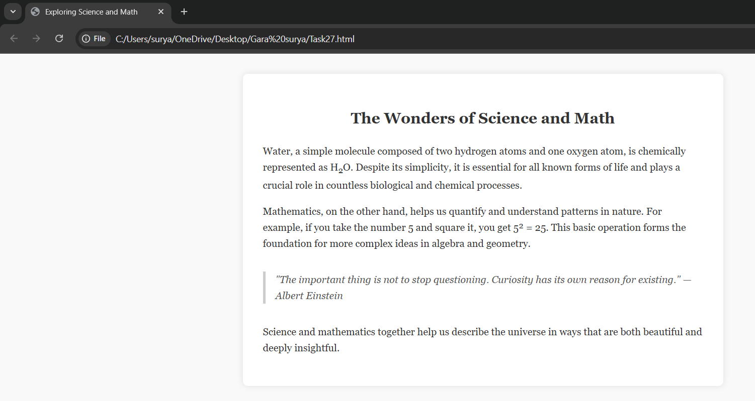

**27**

**Task-28**

**Title:** **Support form with grouped address/contact in "Delivery Info" box.**

**Source code:**

**<!DOCTYPE html>**

**<html lang="en">**

**<head>**

**<meta charset="UTF-8">**

**<title>Support Form</title>**

**<style>**

**body {**

**font-family: Arial, sans-serif;**

**background: #f4f4f4;**

**padding: 2rem;**

**}**

**form {**

**max-width: 600px;**

**margin: auto;**

**background: #fff;**

**padding: 2rem;**

**border-radius: 8px;**

**box-shadow: 0 0 10px rgba(0,0,0,0.1);**

**}**

**h2 {**

**margin-top: 0;**

**}**

**fieldset {**

**border: 1px solid #ccc;**

**padding: 1.5rem;**

**margin-bottom: 1.5rem;**

**border-radius: 6px;**

**}**

**legend {**

**font-weight: bold;**

**padding: 0 0.5rem;**

**}**

**.form-group {**

**display: flex;**

**flex-direction: column;**

**margin-bottom: 1rem;**

**}**

**label {**

**margin-bottom: 0.3rem;**

**font-weight: bold;**

**}**

**input, textarea {**

**padding: 0.6rem;**

**border: 1px solid #ccc;**

**border-radius: 4px;**

**}**

**textarea {**

**resize: vertical;**

**}**

**button {**

**background: #0077cc;**

**color: white;**

**border: none;**

**padding: 0.8rem 1.2rem;**

**font-size: 1rem;**

**border-radius: 4px;**

**cursor: pointer;**

**}**

**button:hover {**

**background: #005fa3;**

**}**

**</style>**

**</head>**

**<body>**

**<form>**

**<h2>Support Request</h2>**

**<div class="form-group">**

**<label for="name">Full Name</label>**

**<input type="text" id="name" name="name" required>**

**</div>**

**<div class="form-group">**

**<label for="issue">Describe Your Issue</label>**

**<textarea id="issue" name="issue" rows="4" required></textarea>**

**</div>**

**<fieldset>**

**<legend>Delivery Info</legend>**

**<div class="form-group">**

**<label for="address">Street Address</label>**

**<input type="text" id="address" name="address" required>**

**</div>**

**<div class="form-group">**

**<label for="city">City</label>**

**<input type="text" id="city" name="city" required>**

**</div>**

**<div class="form-group">**

**<label for="state">State/Province</label>**

**<input type="text" id="state" name="state">**

**</div>**

**<div class="form-group">**

**<label for="zip">ZIP/Postal Code</label>**

**<input type="text" id="zip" name="zip">**

**</div>**

**<div class="form-group">**

**<label for="phone">Phone Number</label>**

**<input type="tel" id="phone" name="phone" required>**

**</div>**

**<div class="form-group">**

**<label for="email">Email Address</label>**

**<input type="email" id="email" name="email" required>**

**</div>**

**</fieldset>**

**<button type="submit">Submit Request</button>**

**</form>**

**</body>**

**</html>**

**Output:**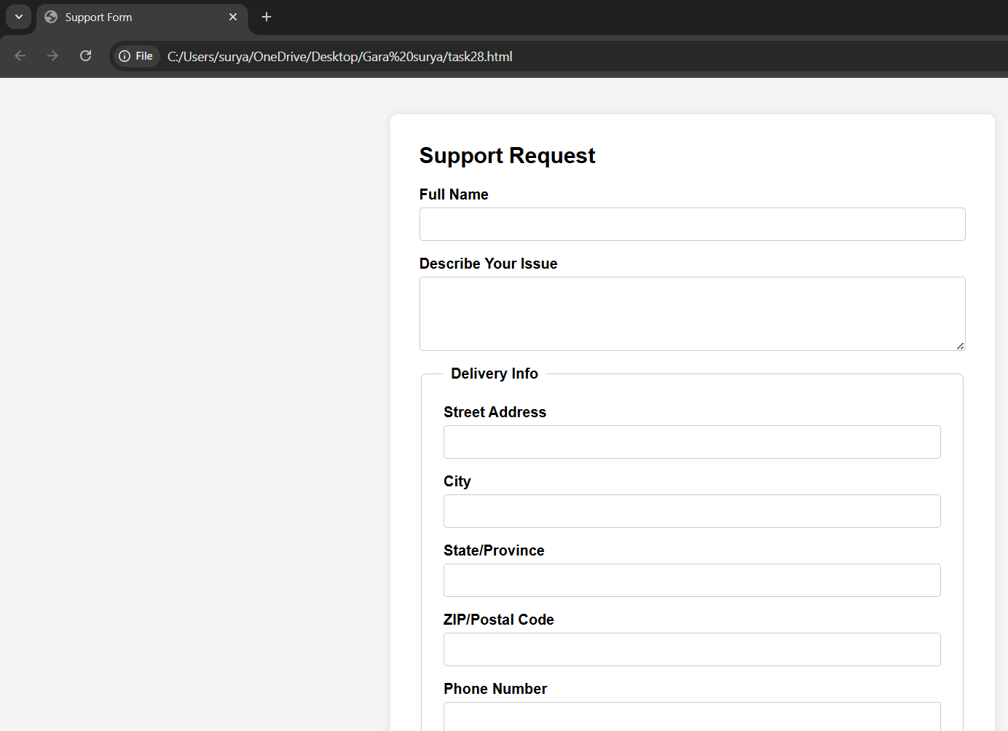

**28**

**Task-29**

**Title:** **Mini photo gallery with image captions under a title.**

**Source code:**

**<!DOCTYPE html>**

**<html lang="en">**

**<head>**

**<meta charset="UTF-8">**

**<title>Support Form</title>**

**<style>**

**body {**

**font-family: Arial, sans-serif;**

**background: #f4f4f4;**

**padding: 2rem;**

**}**

**form {**

**max-width: 600px;**

**margin: auto;**

**background: #fff;**

**padding: 2rem;**

**border-radius: 8px;**

**box-shadow: 0 0 10px rgba(0,0,0,0.1);**

**}**

**h2 {**

**margin-top: 0;**

**}**

**fieldset {**

**border: 1px solid #ccc;**

**padding: 1.5rem;**

**margin-bottom: 1.5rem;**

**border-radius: 6px;**

**}**

**legend {**

**font-weight: bold;**

**padding: 0 0.5rem;**

**}**

**.form-group {**

**display: flex;**

**flex-direction: column;**

**margin-bottom: 1rem;**

**}**

**label {**

**margin-bottom: 0.3rem;**

**font-weight: bold;**

**}**

**input, textarea {**

**padding: 0.6rem;**

**border: 1px solid #ccc;**

**border-radius: 4px;**

**}**

**textarea {**

**resize: vertical;**

**}**

**button {**

**background: #0077cc;**

**color: white;**

**border: none;**

**padding: 0.8rem 1.2rem;**

**font-size: 1rem;**

**border-radius: 4px;**

**cursor: pointer;**

**}**

**button:hover {**

**background: #005fa3;**

**}**

**</style>**

**</head>**

**<body>**

**<form>**

**<h2>Support Request</h2>**

**<div class="form-group">**

**<label for="name">Full Name</label>**

**<input type="text" id="name" name="name" required>**

**</div>**

**<div class="form-group">**

**<label for="issue">Describe Your Issue</label>**

**<textarea id="issue" name="issue" rows="4" required></textarea>**

**</div>**

**<fieldset>**

**<legend>Delivery Info</legend>**

**<div class="form-group">**

**<label for="address">Street Address</label>**

**<input type="text" id="address" name="address" required>**

**</div>**

**<div class="form-group">**

**<label for="city">City</label>**

**<input type="text" id="city" name="city" required>**

**</div>**

**<div class="form-group">**

**<label for="state">State/Province</label>**

**<input type="text" id="state" name="state">**

**</div>**

**<div class="form-group">**

**<label for="zip">ZIP/Postal Code</label>**

**<input type="text" id="zip" name="zip">**

**</div>**

**<div class="form-group">**

**<label for="phone">Phone Number</label>**

**<input type="tel" id="phone" name="phone" required>**

**</div>**

**<div class="form-group">**

**<label for="email">Email Address</label>**

**<input type="email" id="email" name="email" required>**

**</div>**

**</fieldset>**

**<button type="submit">Submit Request</button>**

**</form>**

**</body>**

**</html>**

**Output:**



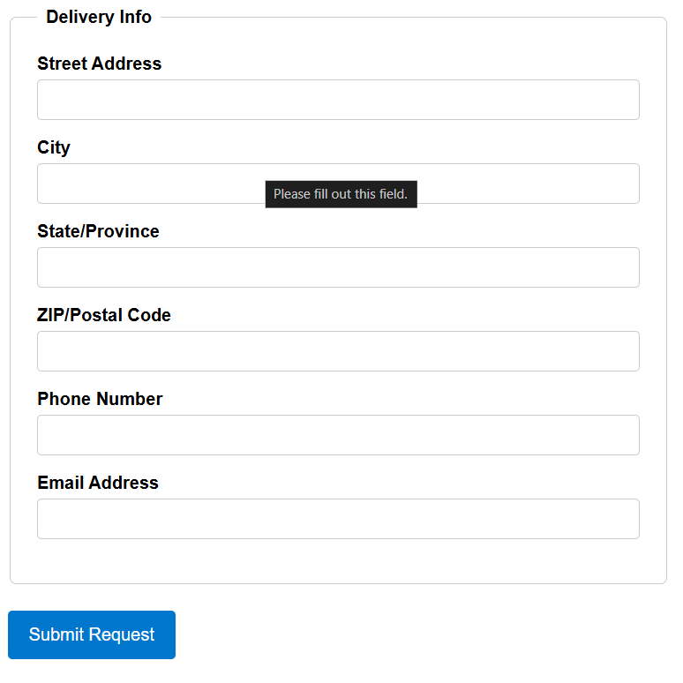

**29**

**Task-30**

**Title:** **Create layout using universal and type selectors with base styles, header, content, and footer**

**Source code:**

**<!DOCTYPE html>**

**<html lang="en">**

**<head>**

**<meta charset="UTF-8">**

**<meta name="viewport" content="width=device-width, initial-scale=1">**

**<title>Basic Layout with Universal and Type Selectors</title>**

**<link rel="stylesheet" href="styles.css">**

**</head>**

**<body>**

**<header>**

**<h1>My Simple Website</h1>**

**</header>**

**<main>**

**<section>**

**<h2>Welcome to the Content Area</h2>**

**<p>This is where your main content goes. It's styled using only type and universal selectors.</p>**

**</section>**

**</main>**

**<footer>**

**<p>&copy; 2025 My Simple Website</p>**

**</footer>**

**</body>**

**</html>**

**/* Universal selector: Reset and base box sizing */**

**\* {**

**margin: 0;**

**padding: 0;**

**box-sizing: border-box;**

**}**

**/* Base styles for body */**

**body**

**font-family: Arial, sans-serif;**

**background-color: #f5f5f5;**

**color: #333;**

**line-height: 1.6;**

**}**

**/* Header section */**

**header {**

**background-color: #444;**

**color: white;**

**padding: 20px;**

**text-align: center;**

**}**

**/* Main content area */**

**main {**

**padding: 20px;**

**background-color: white;**

**max-width: 800px;**

**margin: 20px auto;**

**}**

**/* Section inside main */**

**main section {**

**padding: 10px 0;**

**}**

**/* Footer section */**

**footer {**

**background-color: #444;**

**color: white;**

**text-align: center;**

**padding: 15px;**

**}**

**Output:**

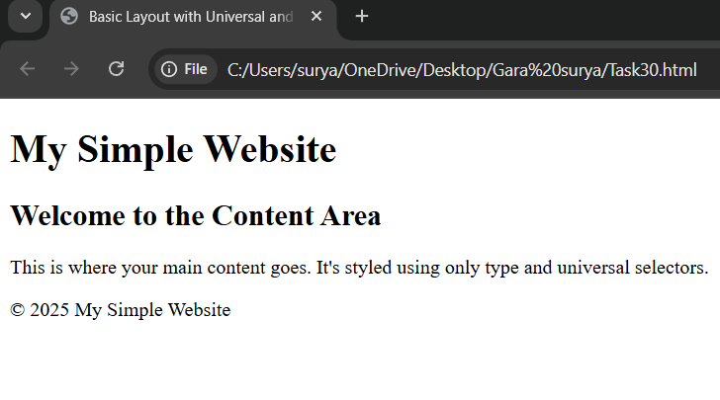

**30**

**Task-31**

**Title: Login form using <fieldset> and <legend> styled bold and larger.**

**Source code:**

**<!DOCTYPE html>**

**<html lang="en">**

**<head>**

**<meta charset="UTF-8">**

**<meta name="viewport" content="width=device-width, initial-scale=1">**

**<title>Login Form</title>**

**<link rel="stylesheet" href="login.css">**

**</head>**

**<body>**

**<form>**

**<fieldset>**

**<legend>Login</legend>**

**<label for="username">Username:</label><br>**

**<input type="text" id="username" name="username"><br><br>**

**<label for="password">Password:</label><br>**

**<input type="password" id="password" name="password"><br><br>**

**<input type="submit" value="Login">**

**</fieldset>**

**</form>**

**</body>**

**</html>**

**Login.css**

**/* Base styles using universal selector */**

**\* {**

**margin: 0;**

**padding: 0;**

**box-sizing: border-box;**

**}**

**/* Body type selector for basic layout */**

**body {**

**font-family: Arial, sans-serif;**

**background-color: #f2f2f2;**

**padding: 20px;**

**}**

**/* Form fieldset */**

**fieldset {**

**background-color: #fff;**

**padding: 20px;**

**border: 2px solid #ccc;**

**max-width: 300px;**

**margin: 0 auto;**

**}**

**/* Style the legend - bold and larger */**

**legend {**

**font-weight: bold;**

**font-size: 1.5em;**

**padding-bottom: 10px;**

**}**

**/* Label and input styles */**

**label {**

**display: block;**

**margin-bottom: 5px;**

**}**

**input[type="text"],**

**input[type="password"] {**

**width: 100%;**

**padding: 8px;**

**margin-bottom: 15px;**

**border: 1px solid #aaa;**

**border-radius: 4px;**

**}**

**/* Submit button */**

**input[type="submit"] {**

**padding: 10px 20px;**

**background-color: #333;**

**color: white;**

**border: none;**

**border-radius: 4px;**

**cursor: pointer;**

**}**

**Output:**

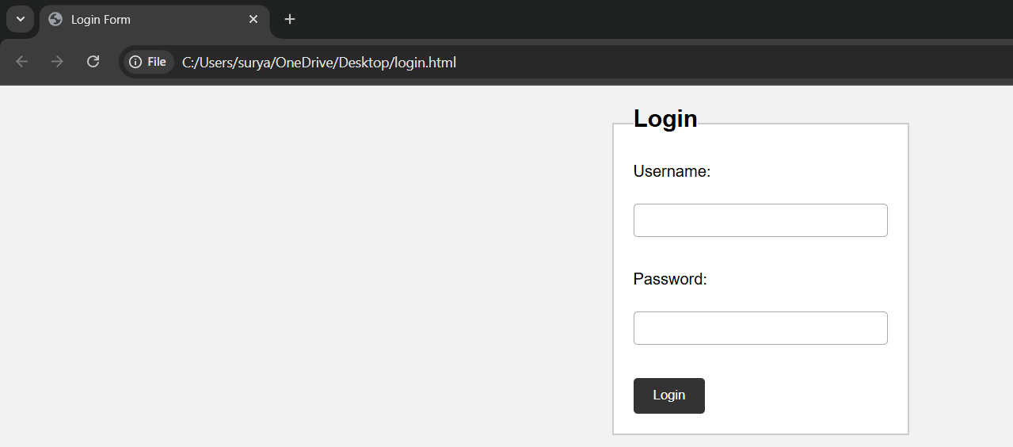

**31**

**Task-32**

**Title:** **Style elements using class and ID selectors: title, paragraphs, heading, background, and padding.**

**Source code:**

**<!DOCTYPE html>**

**<html lang="en">**

**<head>**

**<meta charset="UTF-8">**

**<meta name="viewport" content="width=device-width, initial-scale=1">**

**<title>Class and ID Styling</title>**

**<link rel="stylesheet" href="styled.css">**

**</head>**

**<body>**

**<h1 id="title">Welcome to My Styled Page</h1>**

**<section id="background-section">**

**<h2 id="main-heading">About This Page</h2>**

**<p class="text">This paragraph is styled using a class selector. It has custom font and spacing.</p>**

**<p class="text padded">This paragraph also uses padding through a class.</p>**

**</section>**

**</body>**

**</html>**

**/* ID selector for the page title */**

**#title {**

**font-size: 2.5em;**

**color: darkblue;**

**text-align: center;**

**margin-top: 20px;**

**}**

**/* ID selector for the main heading */**

**#main-heading {**

**font-size: 1.8em;**

**color: #333;**

**margin-bottom: 15px;**

**}**

**/* Class selector for paragraphs */**

**.text {**

**font-family: Georgia, serif;**

**font-size: 1em;**

**color: #555;**

**line-height: 1.6;**

**margin-bottom: 10px;**

**}**

**/* Additional class for padding */**

**.padded {**

**padding: 15px;**

**background-color: #f0f0f0;**

**}**

**/* ID selector for background section */**

**#background-section {**

**background-color: #e9f7ff;**

**padding: 20px;**

**border: 1px solid #ccc;**

**margin: 30px auto;**

**max-width: 600px;**

**}**

**Output:**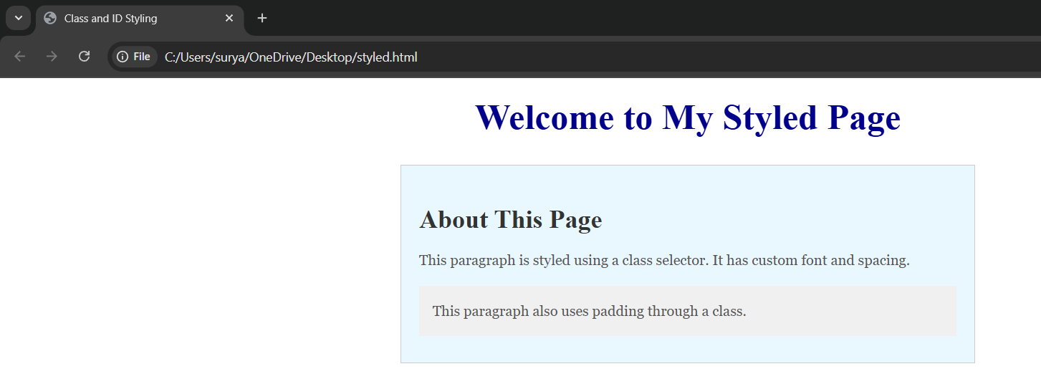

**32**

**Task-33**

**Title:** **Design a timetable using CSS.**

**Source code:**

**<!DOCTYPE html>**

**<html lang="en">**

**<head>**

**<title>Task-33</title>**

**<style>**

**body {**

**font-family: Arial, sans-serif;**

**background-color: aliceblue;**

**}**

**h1 {**

**text-align: center;**

**background-color: darkslateblue;**

**color: white;**

**padding: 10px;**

**}**

**table {**

**width: 100%;**

**border-collapse: collapse;**

**margin: 20px auto;**

**}**

**th, td {**

**border: 1px solid gray;**

**text-align: center;**

**padding: 8px;**

**}**

**th {**

**background-color: lightsteelblue;**

**}**

**94**

**.major {**

**background-color: lavender;**

**font-weight: bold;**

**}**

**.minor {**

**background-color: honeydew;**

**}**

**.skill {**

**background-color: lightyellow;**

**}**

**.lab {**

**background-color: mistyrose;**

**font-weight: bold;**

**}**

**.break, .lunch {**

**background-color: lightgray;**

**font-style: italic;**

**}**

**</style>**

**</head>**

**<body>**

**<h1>Class Timetable</h1>**

**<table>**

**<tr>**

**<th>Day</th>**

**<th>9:00 - 9:45</th>**

**<th>9:45 - 10:30</th>**

**<th>Break</th>**

**<th>10:45 - 11:30</th>**

**<th>11:30 - 12:15</th>**

**95**

**<th>Lunch</th>**

**<th>1:00 - 1:45</th>**

**<th>1:45 - 2:30</th>**

**<th>Break</th>**

**<th>2:45 - 3:30</th>**

**<th>3:30 - 4:15</th>**

**</tr>**

**<tr>**

**<td>Monday</td>**

**<td class="major">Web Interface Techniques</td>**

**<td class="major">Web Application Development using PHP & MySQL</td>**

**<td class="break">Break</td>**

**<td class="minor">App Dev with Python</td>**

**<td class="minor">Data Analytics</td>**

**<td class="lunch">Lunch</td>**

**<td class="skill">CRT</td>**

**<td class="skill">SS</td>**

**<td class="break">Break</td>**

**<td class="major">Foundations of DS</td>**

**<td class="lab">Lab</td>**

**</tr>**

**<tr>**

**<td>Tuesday</td>**

**<td class="major">Foundations of DS</td>**

**<td class="major">Python Programming</td>**

**<td class="break">Break</td>**

**<td class="major">Web Application Development using PHP & MySQL</td>**

**<td class="minor">App Dev with Python</td>**

**<td class="lunch">Lunch</td>**

**<td class="skill">CRT</td>**

**<td class="skill">SS</td>**

**<td class="break">Break</td>**

**96**

**<td class="major">Web Interface Techniques</td>**

**<td class="lab">Lab</td>**

**</tr>**

**<tr>**

**<td>Wednesday</td>**

**<td class="major">Web Interface Techniques</td>**

**<td class="minor">Data Analytics</td>**

**<td class="break">Break</td>**

**<td class="major">Foundations of DS</td>**

**<td class="minor">App Dev with Python</td>**

**<td class="lunch">Lunch</td>**

**<td class="skill">SS</td>**

**<td class="skill">CRT</td>**

**<td class="break">Break</td>**

**<td class="major">Python Programming</td>**

**<td class="lab">Lab</td>**

**</tr>**

**<tr>**

**<td>Thursday</td>**

**<td class="major">Python Programming</td>**

**<td class="major">Web Application Development using PHP & MySQL</td>**

**<td class="break">Break</td>**

**<td class="minor">Data Analytics</td>**

**<td class="major">Foundations of DS</td>**

**<td class="lunch">Lunch</td>**

**<td class="skill">CRT</td>**

**<td class="skill">SS</td>**

**<td class="break">Break</td>**

**<td class="major">Web Interface Techniques</td>**

**<td class="lab">Lab</td>**

**</tr>**

**97**

**<tr>**

**<td>Friday</td>**

**<td class="major">Web Interface Techniques</td>**

**<td class="major">Python Programming</td>**

**<td class="break">Break</td>**

**<td class="minor">App Dev with Python</td>**

**<td class="major">Web Application Development using PHP & MySQL</td>**

**<td class="lunch">Lunch</td>**

**<td class="skill">SS</td>**

**<td class="skill">CRT</td>**

**<td class="break">Break</td>**

**<td class="major">Foundations of DS</td>**

**<td class="lab">Lab</td>**

**</tr>**

**<tr>**

**<td>Saturday</td>**

**<td class="major">Foundations of DS</td>**

**<td class="minor">Data Analytics</td>**

**<td class="break">Break</td>**

**<td class="major">Python Programming</td>**

**<td class="minor">App Dev with Python</td>**

**<td class="lunch">Lunch</td>**

**<td class="skill">CRT</td>**

**<td class="skill">SS</td>**

**<td class="break">Break</td>**

**<td class="major">Web Application Development using PHP & MySQL</td>**

**<td class="lab">Lab</td>**

**</tr>**

**</table>**

**</body>**

**</html>**

**Output:**

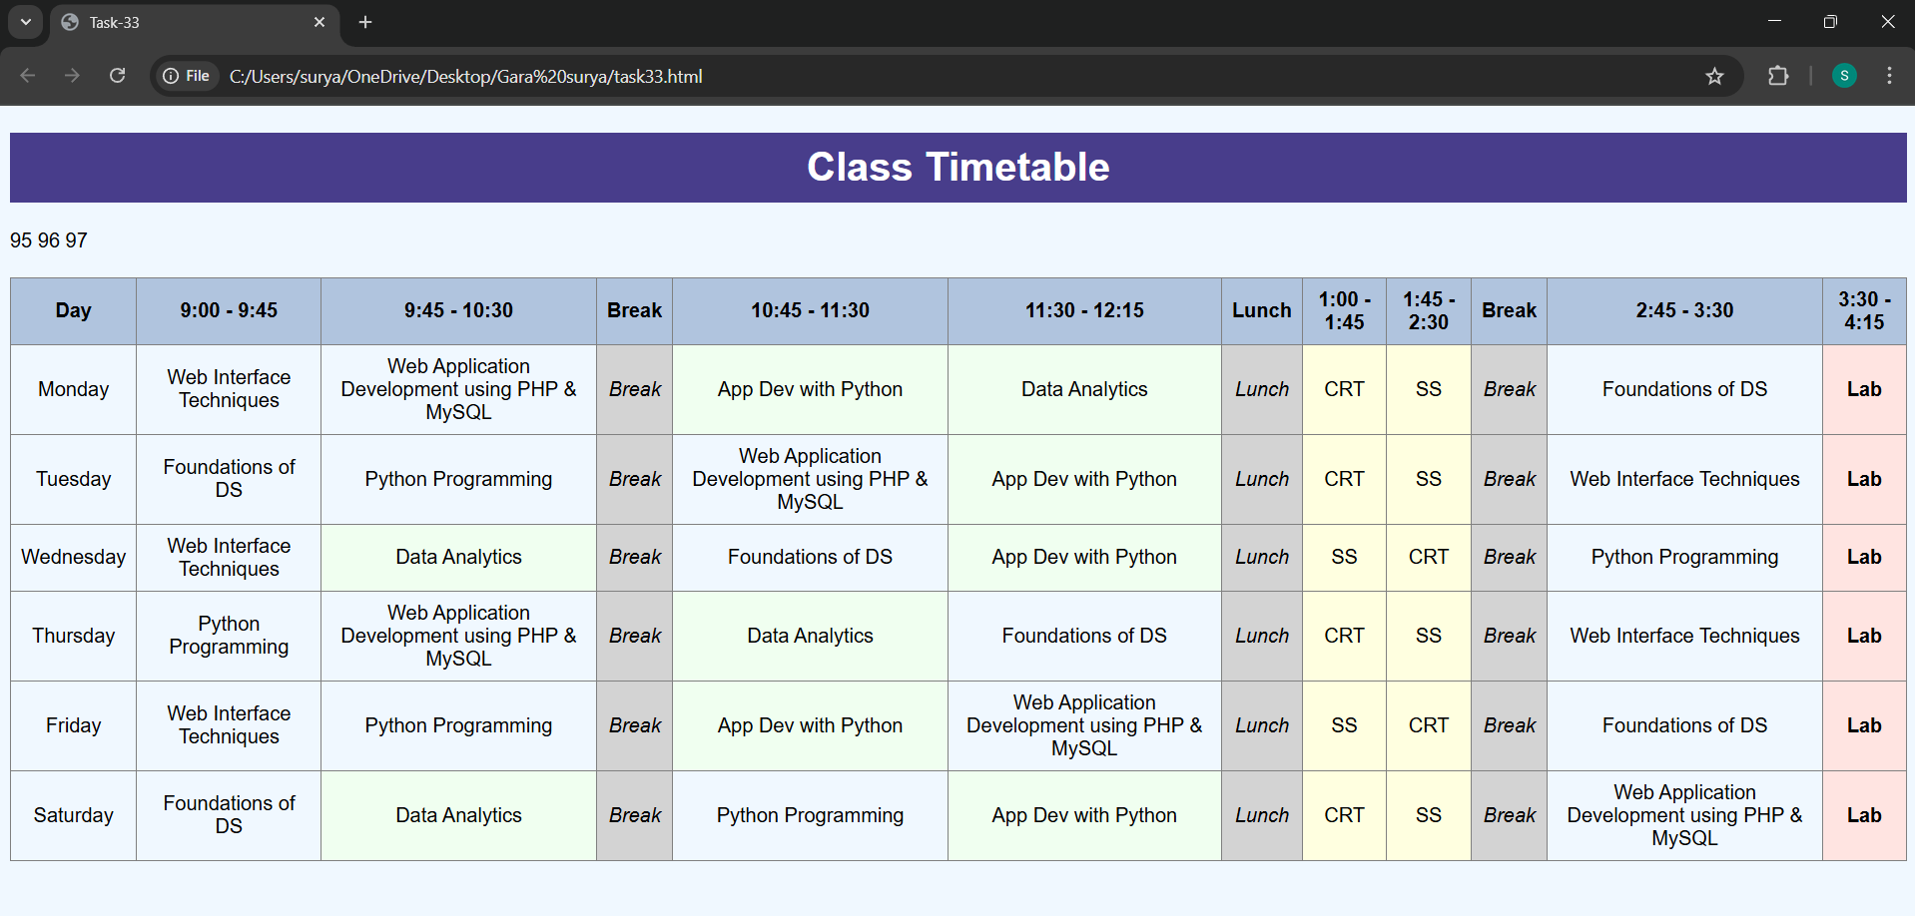

**33**

**Task-34**

**Title:** **Style multiple elements using a class selector (blue text, 18px font).**

**Source code:**

**<!DOCTYPE html>**

**<html lang="en">**

**<head>**

**<meta charset="UTF-8">**

**<title>Class Selector Styling</title>**

**<link rel="stylesheet" href="styles.css">**

**</head>**

**<body>**

**<h1 class="blue-text">This is a Heading</h1>**

**<p class="blue-text">This is a paragraph styled with the same class.</p>**

**<div class="blue-text">This is a div using the blue-text class.</div>**

**<span class="blue-text">This is a span element.</span>**

**</body>**

**</html>**

**/* Class selector for blue text and 18px font size */**

**.blue-text {**

**color: blue;**

**font-size: 18px;**

**}**

**Output:**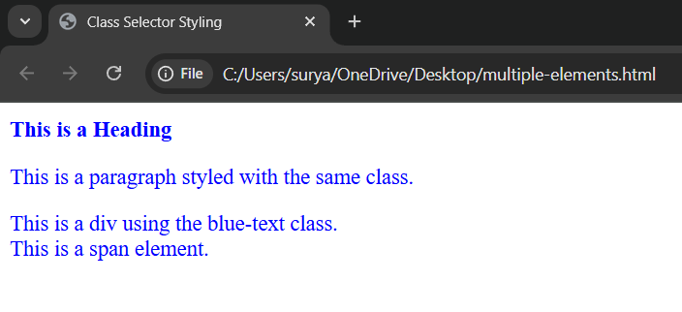

**43**

**Task-35**

**Title:** **Define a class selector for lightgray background, Arial font, and 10px padding.**

**Source code:**

**<!DOCTYPE html>**

**<html lang="en">**

**<head>**

**<title>Task-35</title>**

**<style>**

**.xyz{**

**background-color: lightgray;**

**font-family: Arial, Helvetica, sans-serif;**

**padding: 10px;**

**}**

**#asd{**

**color: black;**

**background-color: khaki;**

**padding: 5px;**

**}**

**</style>**

**</head>**

**<body>**

**<div class="xyz">**

**<p>This is First Paragraph.</p>**

**<p>This is Second Paragraph in the same Class.</p>**

**</div>**

**<p id="asd">This is Third Paragraph which is Out of the Class. Obtains different CSS properties</p>**

**</body>**

**</html>**

**Output:**

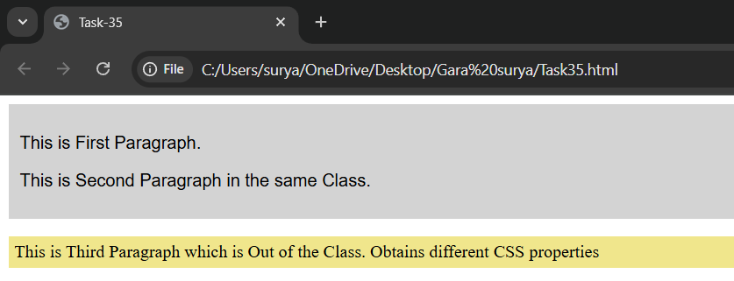

**35**

**Task-36**

**Title:** **Use a class selector to apply black border, 200×100px size.**

**Source code:**

**<!DOCTYPE html>**

**<html lang="en">**

**<head>**

**<title>Task-36</title>**

**<style>**

**.alice{**

**border: 2px solid black;**

**width: 200px;**

**height: 100px;**

**padding: 10px;**

**}**

**</style>**

**</head>**

**<body>**

**<div class="alice">**

**<p>PHP-HYPERTEXT PREPROCESSOR</p>**

**<P>PHP include in HTML code</P>**

**</div>**

**<p>Out of the class so properties not applied to this.</p>**

**</body>**

**</html>**

**Output:**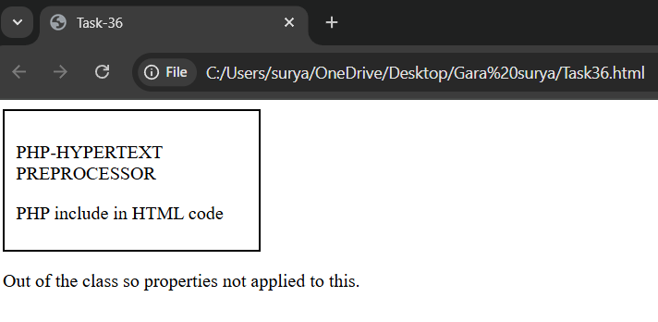

**36**

**Task-37**

**Title:** **Welcome section with centered bold title, left-aligned intro with spacing, and universal reset**

**Source code:**

**<!DOCTYPE html>**

**<html lang="en">**

**<head>**

**<meta charset="UTF-8">**

**<title>Task-37</title>**

**<style>**

**\* {**

**margin: 0;**

**padding: 0;**

**box-sizing: border-box;**

**}**

**h1 {**

**text-align: center;**

**font-weight: bold;**

**font-size: 2.5em;**

**margin-top: 40px;**

**}**

**p {**

**text-align: left;**

**line-height: 1.8;**

**max-width: 800px;**

**margin: 20px auto;**

**font-size: 1.2em;**

**padding: 0 20px;**

**}**

**</style>**

**</head>**

**<body>**

**<h1>Welcome to Our Website</h1>**

**<p>**

**This website is designed to provide insightful resources and engaging content to help you grow and**

**succeed.**

**Explore our articles, tutorials, and tools to get started on your journey. Whether you're a beginner or a**

**pro,**

**there's something here for everyone.**

**</p>**

**</body>**

**</html>**

**Output:**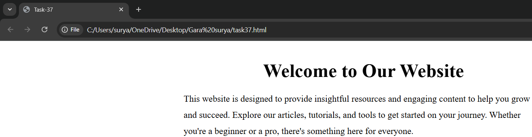

**37**

**Task-38**

**Title:** **Product card with image, name, description, and hover button.**

**Source code:**

**<!DOCTYPE html>**

**<html lang="en">**

**<head>**

**<meta charset="UTF-8">**

**<title>Task-38</title>**

**<style>**

**\* {**

**box-sizing: border-box;**

**font-family: Arial, sans-serif;**

**}**

**body {**

**background-color: whitesmoke;**

**display: flex;**

**justify-content: center;**

**align-items: center;**

**height: 100vh;**

**margin: 0;**

**}**

**.card {**

**background-color: white;**

**width: 300px;**

**border-radius: 12px;**

**box-shadow: 0 4px 8px rgba(0,0,0,0.1);**

**padding: 16px;**

**text-align: center;**

**}**

**img {**

**max-width: 100%;**

**border-radius: 8px;**

**}**

**h1 {**

**font-size: 24px;**

**font-weight: bold;**

**margin: 16px 0 8px;**

**}**

**p {**

**font-size: 14px;**

**background-color: lightgray;**

**padding: 10px;**

**border-radius: 6px;**

**}**

**.buy-btn {**

**margin-top: 12px;**

**display: inline-block;**

**padding: 10px 20px;**

**background-color: green;**

**color: white;**

**border: none;**

**border-radius: 6px;**

**text-decoration: none;**

**transition: background-color 0.3s ease;**

**}**

**108**

**.buy-btn:hover {**

**background-color: darkgreen;**

**}**

**</style>**

**</head>**

**<body>**

**<div class="card">**

**<img src="https://images.pexels.com/photos/205421/pexels-photo-205421.jpeg?cs=srgb&dl=pexels-craigmdennis-205421.jpg&fm=jpg" alt="HP-Victus">**

**<h1>HP-Victus</h1>**

**<p>The HP Victus 15.6" Full HD 144Hz Gaming Laptop is an excellent choice for gamers and users looking**

**for solid performance at a reasonable price. </p>**

**<a href="task24.html" class="buy-btn">Buy</a>**

**</div>**

**</body>**

**</html>**

**Output:**

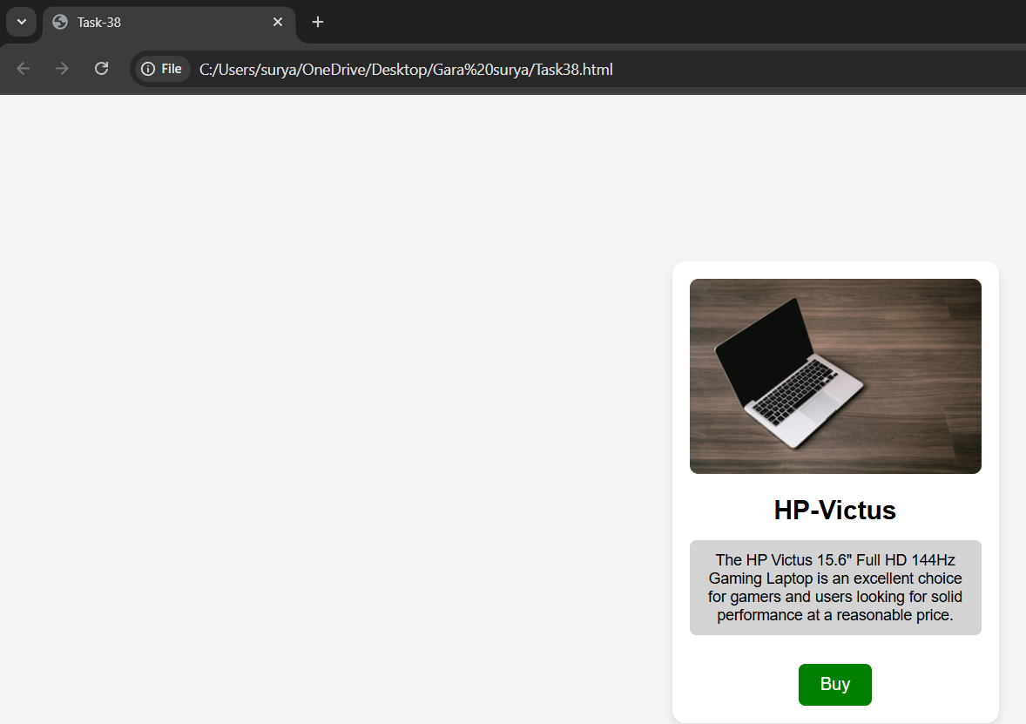

**38**

**Task-39**

**Title:** **Navigation bar with clickable menu, hover color, and active highlight.**

**Source code:**

**<!DOCTYPE html>**

**<html lang="en">**

**<head>**

**<meta charset="UTF-8">**

**<title>Task-39</title>**

**<style>**

**\* {**

**margin: 0;**

**padding: 0;**

**box-sizing: border-box;**

**font-family: Arial, sans-serif;**

**}**

**nav {**

**background-color: navy;**

**padding: 10px 0;**

**}**

**ul {**

**list-style: none;**

**display: flex;**

**justify-content: center;**

**}**

**li {**

**margin: 0 15px;**

**}**

**110**

**a {**

**text-decoration: none;**

**color: white;**

**font-size: 18px;**

**padding: 8px 12px;**

**}**

**.active {**

**background-color: white;**

**color: navy;**

**border-radius: 4px;**

**}**

**.hover-effect:hover {**

**background-color: lightgray;**

**color: black;**

**border-radius: 4px;**

**}**

**</style>**

**</head>**

**<body>**

**<nav>**

**<ul>**

**<li><a href="#" class="active">Home</a></li>**

**<li><a href="#" class="hover-effect">About</a></li>**

**<li><a href="#" class="hover-effect">Services</a></li>**

**<li><a href="#" class="hover-effect">Products</a></li>**

**<li><a href="#" class="hover-effect">Contact</a></li>**

**</ul>**

**</nav>**

**</body>**

**</html>**

**Output:**

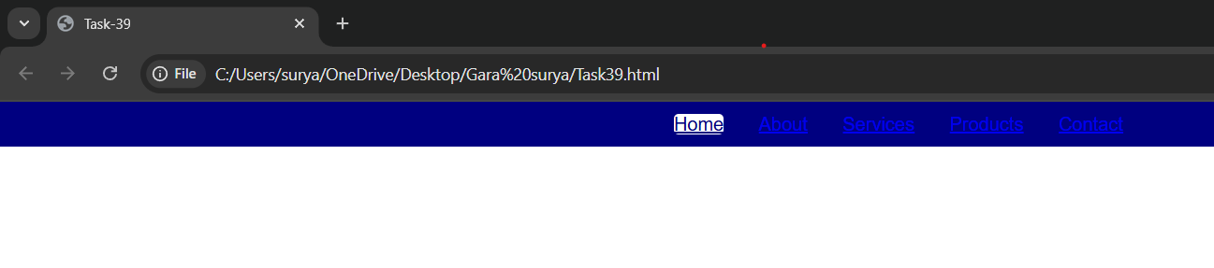

**39**

**Task-40**

**Title:** **User profile card with image, name, bio, and hover button.**

**Source code:**

**<!DOCTYPE html>**

**<html lang="en">**

**<head>**

**<meta charset="UTF-8">**

**<title>Task-40</title>**

**<style>**

**\* {**

**padding: 0;**

**margin: 0;**

**box-sizing: border-box;**

**font-family: Arial, sans-serif;**

**}**

**body {**

**background-color: lavender;**

**display: flex;**

**justify-content: center;**

**align-items: center;**

**height: 100vh;**

**}**

**.profile-card {**

**background-color: white;**

**width: 300px;**

**border-radius: 12px;**

**padding: 20px;**

**box-shadow: 0 4px 8px rgba(0,0,0,0.1);**

**text-align: center;**

**113**

**}**

**img {**

**width: 100px;**

**height: 100px;**

**border-radius: 50%;**

**object-fit: cover;**

**margin-bottom: 15px;**

**}**

**h2 {**

**font-size: 22px;**

**margin-bottom: 10px;**

**}**

**p {**

**font-size: 14px;**

**margin-bottom: 20px;**

**color: #555;**

**}**

**.profile-btn {**

**padding: 10px 20px;**

**background-color: teal;**

**color: white;**

**border: none;**

**border-radius: 6px;**

**cursor: pointer;**

**text-decoration: none;**

**transition: background-color 0.3s ease;**

**}**

**114**

**.profile-btn:hover {**

**background-color: darkslategray;**

**}**

**</style>**

**</head>**

**<body>**

**<div class="profile-card">**

**<img src="https://img.freepik.com/free-photo/young-bearded-man-with-striped-shirt_273609-**

**5677.jpg?semt=ais_hybrid&w=740" alt="User Photo">**

**<h2>John Alice</h2>**

**<p>Web developer passionate about creating beautiful user experiences.</p>**

**<a href="#" class="profile-btn">Follow</a>**

**</div>**

**</body>**

**</html>**

**Output:**

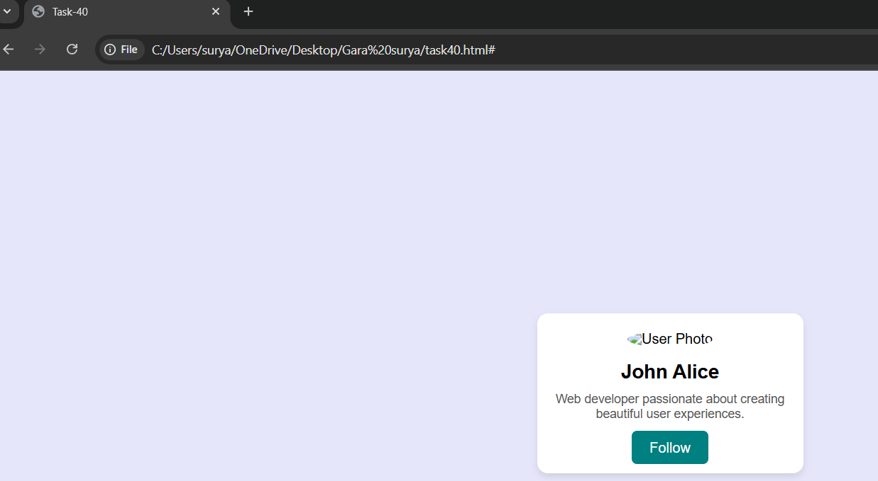

**40**

**Task-41**

**Title:** **Blog layout with title, stacked posts, sidebar, and styles.**

**Source code:**

**<!DOCTYPE html>**

**<html lang="en">**

**<head>**

**<meta charset="UTF-8">**

**<title>Task-41</title>**

**<style>**

**\* {**

**margin: 0;**

**padding: 0;**

**box-sizing: border-box;**

**font-family: Arial, sans-serif;**

**}**

**body {**

**display: flex;**

**flex-direction: row;**

**padding: 20px;**

**background-color: whitesmoke;**

**}**

**.main {**

**flex: 3;**

**margin-right: 20px;**

**}**

**h1 {**

**font-size: 32px;**

**text-align: center;**

**116**

**}**

**margin-bottom: 30px;**

**h2 {**

**font-size: 20px;**

**font-weight: bold;**

**margin-bottom: 5px;**

**}**

**p {**

**font-size: 14px;**

**margin-bottom: 20px;**

**}**

**.sidebar {**

**flex: 1;**

**background-color: lightblue;**

**padding: 15px;**

**border-radius: 8px;**

**}**

**</style>**

**</head>**

**<body>**

**<div class="main">**

**<h1>My Tech Blog</h1>**

**<h2>Post One: Learning HTML</h2>**

**<p>HTML is the foundation of web pages and defines the structure using tags.</p>**

**<h2>Post Two: Getting Started with CSS</h2>**

**117**

**<p>CSS allows you to style your HTML elements and bring your design to life.</p>**

**<h2>Post Three: JavaScript Basics</h2>**

**<p>JavaScript adds interactivity and dynamic behavior to your websites.</p>**

**<h2>Post Four: Introduction to Node.js</h2>**

**<p>Node.js lets you run JavaScript on the server, enabling full-stack development using one**

**language.</p>**

**</div>**

**<div class="sidebar">**

**<h2>About Me</h2>**

**<p>I'm a web enthusiast sharing tips and tutorials on building websites.</p>**

**<h2>Categories</h2>**

**<p>HTML, CSS, JavaScript, Node.js, Web Design</p>**

**</div>**

**</body>**

**</html>**

**Output:**

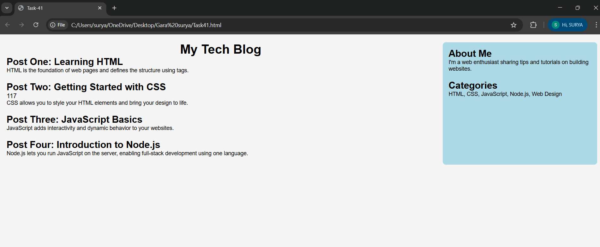

**41**